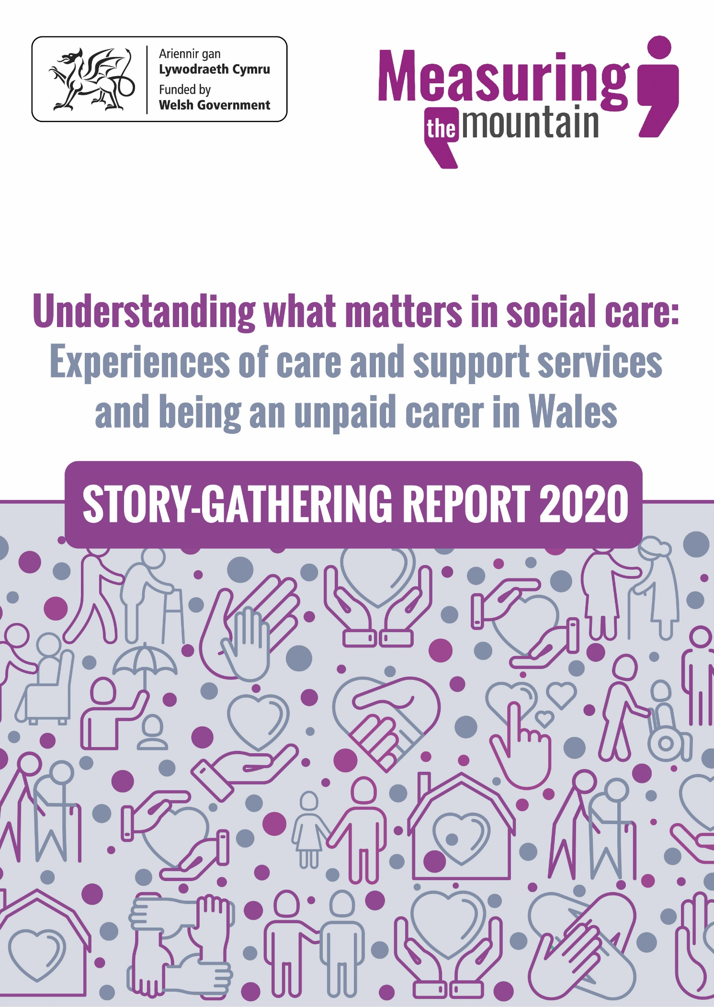
Rachel Iredale and Katie Cooke
Understanding what matters in social care: experiences of care and support services and being an unpaid carer in Wales Pontypridd: University of South Wales
ISBN: 978-1-909838-46-8

Copyright @ University of South Wales, 2020

All rights reserved. No part of this publication may be reproduced, stored in a retrieval system, or transmitted in any form or by any means without written permission from the publishers.

Rachel Iredale and Katie Cooke have asserted their right to be identified as the authors of this work in accordance with the Copyright, Designs and Patents Act 1998.

Contents
BACKGROUND AND METHODOLOGY 5
1. Background and purpose 5
2. Methodology 9
FINDINGS 12
3. The respondents 12
Distribution of respondents from across Wales 13
4. The stories – overview 16
Thematic analysis 19
5. Prevention 20
The labour of care 21
Earlier intervention 29
Valuing Independence 33
Prevention – summary 37
6. Voice and control 38
People and processes 38
The struggle 42
Financial support 48
Being person-centred 51
Voice and control – summary 57
7. Multi-agency working 58
Seamless services 58
Transition and change 63
Multi-agency working – summary 67
8. Co-production 68
Working together 68
The role of community 74
9. Well-being 80
Recognising mental health needs 80
Valuing unpaid carers 83
Embracing the role of the family 86
CONCLUSIONS 91

10. Conclusions and context 91
11. Thanks and acknowledgements 94
12. Annex 1 – SenseMaker framework 95

Table of figures
Figure 1: Distribution of respondents across Wales based on postcode prefixes. 13
Figure 2: Demographic breakdown of respondents. 14
Figure 3: Breakdown of stories against setting, service or provider. 17
Figure 4: Responses to the question ‘How do you feel about your story overall?’ 18
Figure 5: Comparison between how people who are unpaid carers and people who are not responded to the question ‘How do you feel about your story overall?’ 18
Figure 6: Overview of the key themes to emerge from the stories. 20
Figure 7: Breakdown by gender of average number of hours a week spent looking after, caring for or helping someone. 22
Figure 8: Word cloud generated from stories shared by unpaid carers. 25
Figure 9: Responses to the statement ‘You have been supported to prevent your situation from getting worse’. 29
Figure 10: Correlation between people being able to discuss what mattered to them and feeling supported to prevent their situation from getting worse. 34
Figure 11: Responses where people were treated as an equal, with kindness and as knowledgeable, tracked across whether they got what they felt they needed, had a choice and were listened to. . 36
Figure 12: Responses where people felt they had got what they needed, were listened to and had a choice in the support they received. 39
Figure 13: Responses where people felt they had not got what they needed, were not listened to and had not had a choice in the support they received. 43
Figure 14: Word cloud generated from the stories of people who said they were disabled. 53
Figure 15: Responses to the statement ‘The different services and providers worked together well’. 58
Figure 16: Responses to how people felt about their experience grouped against whether different services and providers had worked together well. 59
Figure 17: Responses to the question ‘Who influenced what had happened?’. 69
Figure 18: Responses where care staff or other professionals had been the main influence in their story tracked across whether respondents had got what they felt they needed, had a choice and were listened to. 70
Figure 19: Responses relating to community groups and activities where people felt they got what they needed, were listened to and had a choice in their support. 74
Figure 20: Responses relating to community groups and activities where people felt they were treated as an equal, with kindness and as knowledgeable. 75
Figure 21: Word cloud generated from the stories shared by women. 89
Figure 22: Word cloud generated from the stories shared by men. . 89

BACKGROUND AND METHODOLOGY

Background and purpose

  - Measuring the Mountain is a community-based action research project supported by Welsh Government as part of its commitment to evaluate the early impact and implementation of the Social Services and Well-being (Wales) Act 2014.

  - Responding to the 2011 White Paper, Sustainable Social Services for Wales: A Framework for Action, the Social Services and Well-being (Wales) Act 2014 came into force on April 6th 2016. It provided a new legal framework for improving the well-being of people who need care and support and carers who need support. The Act offered an opportunity to transform the delivery of social care, putting people at the centre of delivery, encouraging more collaboration and partnership working, and extending a clearer offer of support to carers.

  - The approaches outlined in the Act were galvanised by subsequent Welsh Government policy and legislation that clearly set out the need for sustainable services that worked closely with people and communities. Responding to the Parliamentary Review of Health and Social Care, published in 2018, A Healthier Wales outlined a ‘whole system approach to health and social care’ with an emphasis on ‘seamless services’ and a more holistic approach to supporting people’s health and well-being.

  - This strengthened positions previously laid out, including in the Well-being of Future Generations (Wales) Act 2015, which outlined new duties for public bodies that put well-being at the heart of service delivery. It legislated for improved ‘social, economic, environmental and cultural well-being in Wales’, implemented against seven well-being goals, including one specific to creating a healthier Wales.

  - Fundamental to the Social Services and Well-being (Wales) Act 2014 and to policy within Wales more widely, is working more closely with people and ensuring that the voices of people in Wales are heard in decision-making processes that affect them. To support this, and to ensure the successful implementation of the Act, on March 31st 2016, in a written statement, the then Minister for Health and Social Services, Mark Drakeford AM, set out a commitment to evaluate the Act.

  - This commitment involved three phases, the third of which was an independent, long-term evaluation to commence in the third year of the implementation of the Act. Measuring the Mountain was commissioned to work alongside this evaluation to capture the experiences of people using care and support services or providing support to others in their capacity as unpaid carers.

  - It is worth noting that implementing the Act is complex work that is influenced by a range of factors at local, regional and national levels. The 22 local authorities in Wales, the five health board areas and the activity of the third sector, all bring their own influences; and while the Social Services and Well-being (Wales) Act 2014 replaced a raft of earlier legislation, it still operates with and alongside a range of other Acts, polices and processes. This diverse legislative landscape includes the Housing (Wales) Act 2014, Regulation and Inspection of Social Care (Wales) Act 2016, and the Local Government (Wales) Act 2014.

  - Beyond this, the impact of the 2008 financial crisis and subsequent austerity measures continues to be felt by public bodies. Local authorities continue to experience financial pressures and ‘cuts in local government funding and wider austerity impacts are significant in shaping the context in which the Act is being implemented’.

  - Finally, there is considerable breadth to the Social Services and Well-being (Wales) Act 2014 and the range of services and sectors that are required to operate under it and in conjunction with one another. In evaluating the implementation of the Act, consideration must be given to the various, and at times, competing influences that impact upon it.

  - Following the success of Measuring the Mountain’s first year of activity, further sponsorship was secured to deliver the next phase of the project from May 2019 to October 2020 hosted at the University of South Wales. This end date was extended to December 2020 following the outbreak of Covid-19 and subsequent reorganising of the project’s timeline.

  - Building on the first phase of the project, the intention was to deepen knowledge and understanding of the experiences of people receiving care and support and of unpaid carers, with a view to informing positive and practical change. This was particularly in relation to key demographics that had been less well represented in the earlier work: people from black, Asian and minority ethnic communities, younger people (those aged 25 and below) and older people (those aged 65+).

  - The specific aim, as outlined in the proposal to Welsh Government, was:
To understand the early impact of the Social Services and Well-being (Wales) Act 2014 and people’s experiences of social care, particularly the factors that contribute to whether experiences are negative or positive, so that recommendations can be made that will improve well-being outcomes for people who need care and support and carers who need support.

  - As with the work undertaken in 2018 / 19, this phase of the project consisted of two core methods of inquiry, supporting Measuring the Mountain to engage with people in Wales to produce an authentic, experience-based assessment of care and support provision:

- A distributed ethnographic approach using SenseMaker to collect stories from people who use care and support services and from unpaid carers
- A Citizens’ Jury to focus the inquiry towards addressing key questions arising from the stories that had been collected.

  - SenseMaker is a tool specifically designed to support ethnographic research, allowing for data collection to be scaled up and undertaken in a consistent manner across large demographic areas or population groups. Trends and themes are identifiable from the data provided by participants in the form of their individual stories and responses to questions.

  - The tool provides a framework for guiding participants through a story-telling journey. It is designed to support a co-productive, citizen-centred approach to monitoring, evaluation, improvement and action. As such, SenseMaker fits well with the purpose of Measuring the Mountain, providing participants with voice and control, capturing felt experiences and providing a consistent manner in which to do this across Wales and different demographic groups.

  - SenseMaker has been used globally in a variety of environments to understand complex situations or relationships. These include examining entrepreneurship among women in Tajikistan, empowering disabled people in Belarus and understanding people’s experiences of war in Yemen. Locally, it was used in south Wales as part of the Valleys Stories work (part of the Valleys Task Force) to understand more about how people felt about their local community, the factors that contributed to those feelings, and who or what could make a difference to those feelings and the community as a whole.

  - Gathering stories and conducting a Citizens’ Jury are robust approaches to independent qualitative research that prioritise citizen voice. They had proved effective as methods for public involvement in 2018 / 19 and were agreed by the Steering Group to be the most appropriate approach to continuing this work in 2019 / 20. This report focuses on the story-gathering work, a report from the 2020 Online Citizens’ Jury can be found at www.mtm.wales.

  - The Steering Group responsible for delivering the work of Measuring the Mountain consists of a wide and diverse membership, the details of which are provided in section 11 of this report. This is a voluntary and unpaid enterprise, blending multi-sectoral representation, personal passion, practical insight, expertise and knowledge. Members of the group bring first-hand experience of using care and support services, supporting others, technical expertise and a profound commitment to ensure those who are most vulnerable in Welsh society receive a service to enable them to live a full and meaningful life.

Methodology

  - SenseMaker frameworks consist of a range of question types, each yielding different forms of output that can be presented in a variety of ways. Measuring the Mountain’s framework guided respondents through sharing their story, adding context and detail to this story and then providing brief demographic information about themselves.

  - The question types utilised included free text questions, sliding scales, multiple choice and ‘triads’. Triads ask respondents to consider three factors in relation to one another and place a mark in a triangle to indicate their strength of feeling about those three factors. Trends emerge when marks cluster in areas of the triads and the corresponding stories are examined.

  - The process for outlining, drafting, testing and finalising the framework took two months (June and July 2019). This work was undertaken by the Steering Group, with the support of two local community groups who volunteered to share experiences with the project as part of the testing phase. The full framework can be seen in Annex 1.

  - To ensure the approach taken by the project was ethically sound and consistent with best practice research methods, Measuring the Mountain applied to the University of South Wales’ low-risk ethics panel for approval of the project’s work. This was granted in July 2019 and the story-gathering activity ran from August 1st 2019 to May 31st 2020.

  - The SenseMaker framework was produced in English and Welsh and made available as an online tool, accessed via a link on the project website. Paper copies of the framework were also produced and the framework could be accessed using an app which included the option for a respondent to audio record their experience.

  - The primary approach for gathering stories was to ask organisations to invite Measuring the Mountain to attend groups, activities and events where people could speak to someone from the project to share their story. This method was straightforward for organisations to engage with and created a range of opportunities for the project to gather stories.

  - The option for organisations to gather stories on behalf of the project was also available and was supported by a range of resources provided on www.mtm.wales. These were supplemented where needed by face-to-face meetings and mini-workshops delivered by the Project Manager.

  - Stories were gathered via three primary channels:

- Attending events, community groups and hubs where people could share their story with someone from the project or submit their story themselves with support, as needed, from project staff
- People went online and shared their story themselves using the portal
- An external organisation gathered stories on behalf of the project.

  - The project used a combination of purposive and snowball sampling techniques to reach people. Initially the project employed purposive sampling in contacting organisations across Wales that are known to support large numbers of people likely to have a story to share; these included networks, umbrella bodies and national organisations. Steering Group members supported this activity, sharing information with their networks and colleagues.

  - At the same time, people were encouraged to further disseminate information on the project’s behalf and to share the link to SenseMaker so that awareness about the opportunity to submit a story was raised. These approaches built on the reputation developed by the project during its 2018 / 19 work and the enthusiasm of organisations to participate and have the voices of those they worked with heard.

  - People engaged with the project voluntarily, self-selecting to participate and choosing which experience they wanted to share. This approach of creating opportunities for people to share what mattered to them was an important component of the project, allowing people to focus on experiences that stood out for them.

  - It is important to note that the methodology employed by Measuring the Mountain introduces a risk of bias. Organisational or individual agendas may have contributed to respondents deciding to engage with the project. Similarly, those agendas may have contributed to organisations or individuals choosing not to engage with the project.

  - It is also important to note that, given the number of people who use care and support services in Wales, the number who are unpaid carers and the sampling methodology employed by the project, Measuring the Mountain’s work cannot be described as statistically representative of a wider population. However, it is a qualitative snapshot of people’s lives and indicative of trends, themes and perspectives that should be acknowledged and addressed.

  - The individual experiences gathered by the project and shared within this report are, necessarily, from that individual’s point of view. As such, they offer valuable insight to people’s perspectives and understanding, including gaps between what has been legislated for and what people describe experiencing.

  - Critical to this, was the freedom for respondents to share any experience that stood out to them. This was a key element of the story-gathering and yielded a breadth of narratives across a range of topics. In some cases, stories related to extremely difficult or inappropriate situations; these were escalated as appropriate by the individuals gathering the stories.

  - In March 2020 both the UK Government and Welsh Government began issuing guidance in response to the Covid-19 pandemic. Chief among this was a requirement that face-to-face interactions, across all sectors, be halted. The opportunity to share stories over the phone, or over Skype, WhatsApp video calling, or similar, was promoted by the project. Uptake of this digital approach however was low with fewer than 20 stories gathered in this way.

FINDINGS

The respondents

  - Measuring the Mountain gathered 520 stories from 421 individuals across Wales. These stories were gathered at events and community groups, hosted by a range of bodies within the care and support sector, by members of the Measuring Mountain project group. Stories were also gathered by third parties on behalf of the project, as well as being submitted by individuals themselves. See Annex 2 for a list of partner organisations.

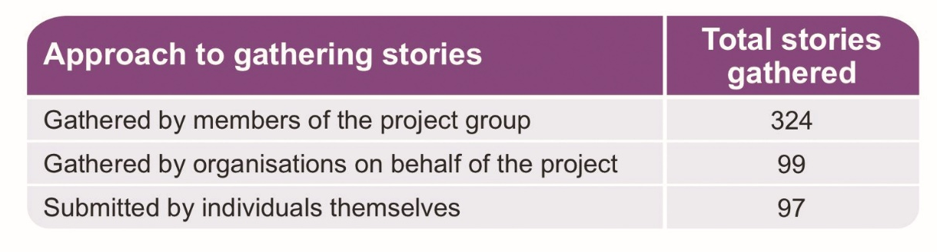

  - Of the stories, 19% (97 stories) were self-completed, and 81% (423 stories) were gathered by someone on behalf of the project. Although data on this matter was not specifically collected, a number of factors are likely to have played a role in people preferring to share their story with a person rather than completing the questions themselves, primary among them:

- People often commented that being able to talk about their experiences was positive
- Several people commented that what they were sharing was upsetting to them, and that typing it into an online form was an unappealing prospect.

  - The 421 respondents came from across Wales: figure 1 shows their distribution across Wales and a full demographic breakdown of these individuals can be seen in the table opposite (figure 2).

  - As can be seen, nearly 68% of respondents were women, 40% of respondents were disabled and 46% had caring responsibilities. Of that 46%, 78% were female and 19% (36 of 193) were disabled. Respondents ranged in age from 12 to 99 with 28% of respondents aged 65 and above.

Distribution of respondents from across Wales
Figure 1: Distribution of respondents across Wales based on postcode prefixes. Markers are in the centre of the geographic area for that postcode prefix and their height indicates the number of times that prefix was given by respondents.
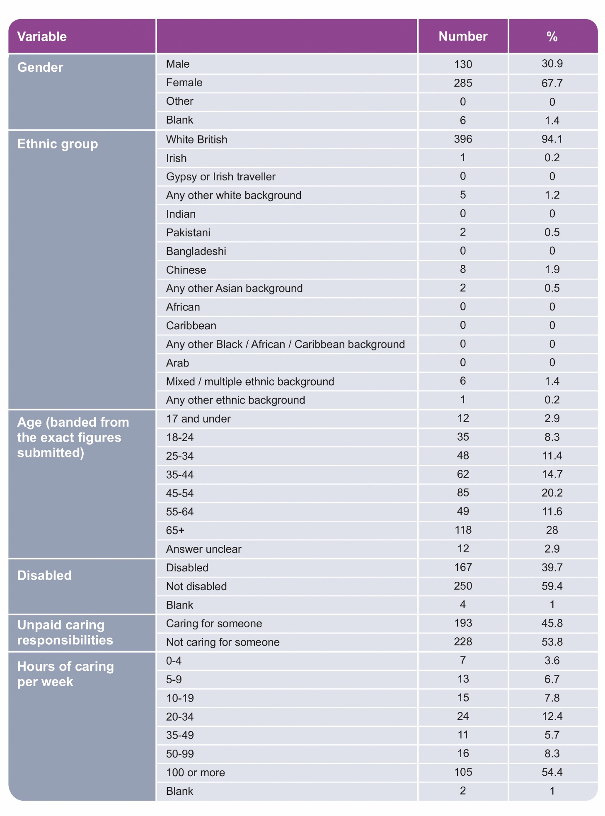
Figure 2: Demographic breakdown of respondents

  - As has been described earlier in the report, the intent had been to gather a higher proportion of stories from several key demographics, including people from black, Asian and minority backgrounds, than in 2018. However, 94% of respondents in 2019 /20 identified as white-British, with only 6% of respondents coming from a black, Asian or minority ethnic background.

  - The efforts made by the project to increase the number of stories from people from black, Asian and minority ethnic backgrounds did not yield the engagement levels hoped for. Whilst other demographics, younger people and people aged 65+, were better represented in this year’s data sample, the lower levels of engagement from black, Asian and minority ethnic communities may indicate a flaw in the delivery of the sampling approach.

The stories – overview

  - As has been described, 421 individuals submitted 520 stories to the project, comprised of 85,000 words. Of the 520 stories, 99 were submitted by people who had already submitted at least one other story. Many people described complex situations in which being an unpaid carer or using care and support services was a fundamental element of their life; sharing several stories enabled them to better describe that complexity. Of the people who shared more than one story, most only shared two and the most that any one person shared was eight stories.

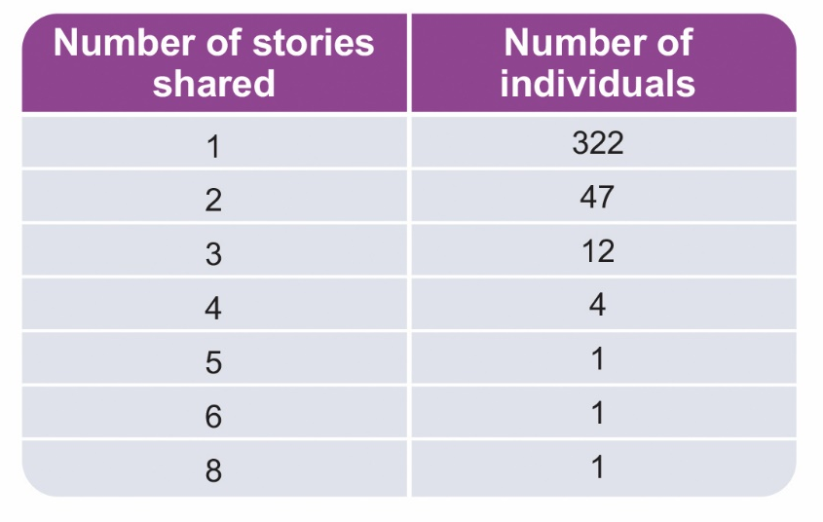
  - Once respondents had shared their stories, they were asked to identify which service, setting or provider the story most related to, with up to three options being selected. As can be seen in figure 3, community support and activities, support for carers and health were the aspects most commonly identified.

  - The category of ‘other’ was selected, and the free text box associated with it completed, 41 times. Housing was listed 14 times, and work or employment nine times. Of the other topics, bereavement, volunteering and assessment processes were each listed twice.

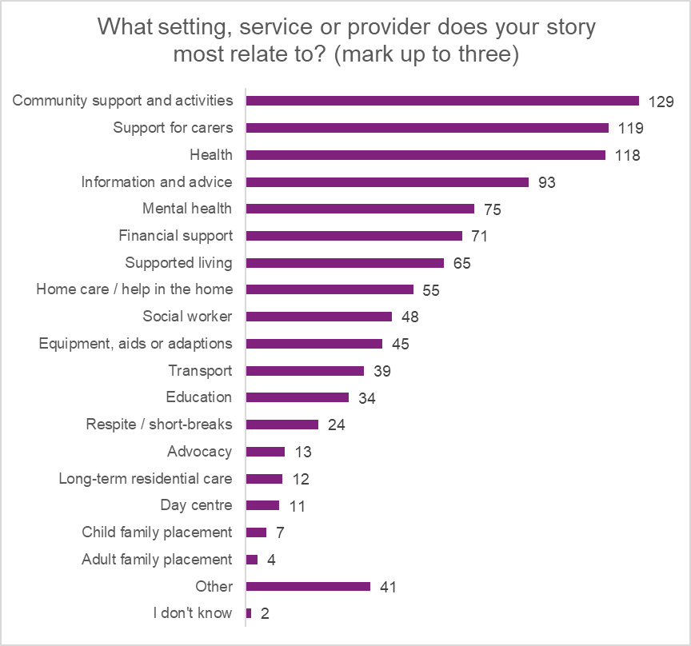
Figure 3: Breakdown of stories against setting, service or provider as identified by the respondent.

  - After they had shared their story people were asked how they felt about it overall. 38% felt positively about their story and 51% felt negatively.
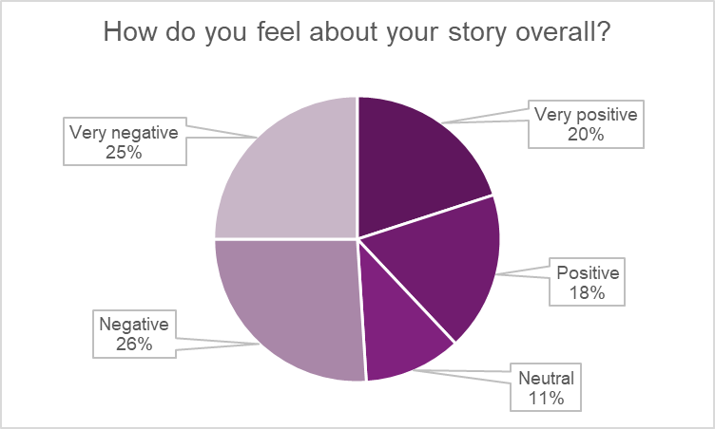
Figure 4: Breakdown of people’s responses to the question ‘How do you feel about your story overall?’ Response total 520, n/a count 0.
  - When stories were broken down in relation to whether someone was an unpaid carer or not, it could be seen that the experiences of carers were broadly less positive than those of people who did not provide care for anyone.

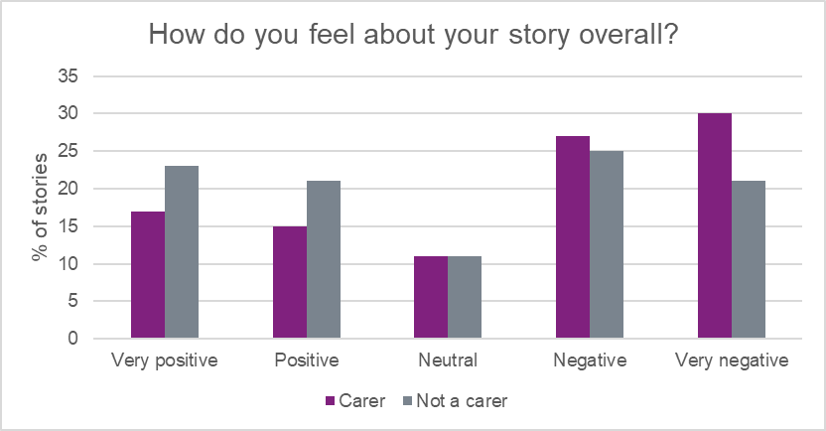
Figure 5: Comparison between how people who are unpaid carers and people who are not responded to the question ‘How do you feel about your story overall?’ Response total 520, n/a count 0.
  - Respondents were then asked to identify who needed to hear what they had said. They were provided with six options (just me, other members of the public, social care staff, managers of organisations providing social care, government / politicians and other), and people could tick as many as applied.

  - Of the responses, 84% felt that government and politicians should hear what they had said, suggesting an appetite among people for their voice to be heard and for the sharing of experiences to not focus only on best practice or complaints. The day-to-day includes much that is valuable and respondents were clear about their desire to share this insight.

Thematic analysis

  - The principles of the Social Services and Well-being (Wales) Act 2014 are:

- Prevention
- Voice and control
- Multi-agency working
- Co-production
- Well-being.
These principles underpin the Act itself and the way it should be implemented. To maintain consistency, they have been used to guide the process of analysing the stories and the qualitative data contained therein. Stories were coded individually by three members of the Steering Group, drawing on their extensive academic and research backgrounds to ensure a robust process and the highest level of objectivity.
  - This approach informed the 12 main themes that emerged as stories were aggregated and considered collectively. Finally, these themes were seen to fit within the principles of the Act and ordered accordingly to create an appropriate analytical framework.

  - The nature of the principles is such that they reinforce, rely on and inform one another so that people’s individual experiences can relate to several or all of them. The framework opposite (figure 6) outlines how the themes have been organised and emphasises the holistic and interconnected relationship between different principles and their impact upon individual well-being.

  - The principles, and themes that sit under them, are discussed in turn with stories used throughout to illustrate the key points; each section ends with a summary highlighting key findings, particularly those relating to the factors that contributed to experiences being positive or negative.

Figure 6: Overview of the key themes to emerge from the stories and the principles of the Act under which they sit.

Prevention

  - Across the narratives, three key themes emerged in relation to prevention and supporting people so that their situation did not deteriorate or worsen. These were:

- The labour of care
- Earlier intervention
- Valuing independence.

  - Understanding the need for preventative measures, and how best to implement them, requires a wide lens that recognises the high levels of unpaid care and support that are provided in the home and the community.

  - Implementing approaches to support the efforts of unpaid carers and enabling people to live well in ways that suit them is critical. Similarly, creating avenues for offering earlier intervention and recognising that a person’s independence is vital to them, and also vital to a successful preventative agenda, was evidenced in a number of stories.

The labour of care

  - Of the individuals who submitted stories, 46% (193) said that they looked after, cared for or helped someone, and of these, 54% (105) said that they cared for someone for 100 or more hours a week. Women reported undertaking significantly more caring activity than men.

  - Caring for someone is a labour, often of love, but one that creates pressures and brings unexpected challenges. Recognising this, and supporting unpaid carers to prevent their, and their loved ones’, situation from deteriorating emerged from a number of stories as an urgent priority.

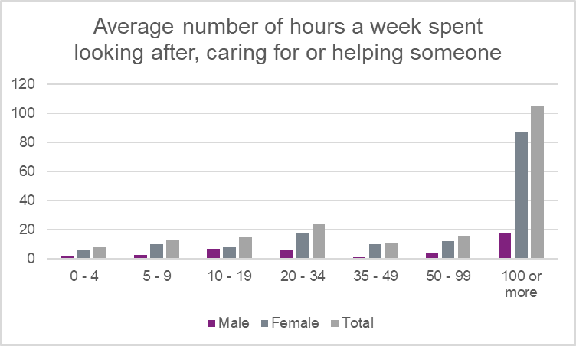
Figure 7: Breakdown by gender of average number of hours a week spent looking after, caring for or helping someone.

  - Stories from unpaid carers, particularly from those providing 100 or more hours a week of support, demonstrate the relentless and full-time nature of the roles being performed. The kind of labour required to care for someone is explicitly stated in a number of stories and alluded to in many more. Stories highlight the complexity of the role, the emotional and mental impact of being a carer and the psychological and physical cost. Guilt, failure and isolation were recurring themes.

Firstly as a carer I understand other carers and something of what they have to put up with. If you are not a carer you cannot understand why you would have to put up with everything thrown at you, day after day, for months, for years. The councils or government bring forward various provisions or Acts to help carers but because of cuts they just become words not actions. Carers are unfortunately easily pushed around because they won’t fight back A carer, for those who don’t know is this - a person who willingly undertakes the total care of another person, no matter what the cost, be it financial, social or personal. A carer is always there day and night, ready to help. A carer is a person who puts their life, emotions and thoughts on hold. This is so that the carer can accommodate the many stresses, problems and responsibilities that caring brings. A carer gives themselves completely to the cared for and is always going the extra mile…
I’m really exhausted, constant battle every day. We’ve got a routine, which is lucky, but it’s never ending, always fighting. Getting to my appointments and hers and rearranging. The stigma is terrible, never thought it would be so bad with friends and family - people drift into the background. You get more and more isolated.

She (mum) was living by herself 18 months ago and then moved in with me - she's 89. She lives in the front room - I've put handrails and toilet and things in downstairs for her. I need to be able to breathe, the mere fact that she's there all the time. She tries to help. If I go anywhere she wants to come with me…

My brother is not allowed to go anywhere unaccompanied, therefore it is my responsibility to take him to his doctors or hospital appointments and anywhere else he needs to go. As his sister I feel that it is my duty to do this, but I often don’t have a say in how it affects me, because he is the one who is unwell…

  - For many, personal sacrifice was an inherent part of caring for someone, often with emotional, physical or financial consequences. Many of the stories highlighted short-term measures or measures that would likely fail without further intervention, illustrating the uncertainty many unpaid carers face.

The huge fear while I was pursuing my sons moving out was what would happen to me? All I was used to was caring - you lose confidence, you don’t mix, don’t have employment experience - you’re a good person but can be stuck. It was because I was on my own - my husband had left just before my younger son had his fit. The stress it creates, the tiredness, you lose yourself as a person…

Our daughter requires a high level of support. Changes to funding mean she has lost over half of her hours of support. My wife and I are now using our pension pots to help fund her support and top what has been taken away.

I work full time and care for my mother and father who are in their 80s... They both have refused help saying, 'our family will care for us'. This impacts negatively on my life as I have a full time demanding job, grandchildren and a partner. However you feel so guilty if you don't do your 'duty' and continue to care. I am told that I have the right to refuse being a carer but how can you refuse?

…I’m on meds for depression and anxiety. Been running on empty. You can do it for so long and then you collapse. I do everything - it’s not just about caring and then going home. I can’t just up and go, I have to consider him - I wouldn’t have it any other way but you have to consider it. I can’t leave him for more than a few hours…

  - In spite of the sacrifice described in many stories by unpaid carers, it was clear the driving force behind their commitment and hard work was the love they felt for the individual for whom they were caring. They were motivated by wanting their loved one to have a good quality of life and were often prepared to sacrifice their own needs to secure this.

I need to find a job that doesn't kill me - I want to work nights so I have the days free to help mum. I did a 7 hour shift and it knocked me back. I had an accident in 2018 and was really struggling. I need to find a job that doesn't fatigue or hurt me - I do a lot of yoga and would like to go to the gym but I can't afford it. Carers' Allowance isn't enough - I need more money to pay rent, and for my children.

I care full time for my partner. I haven’t got any complaints. My partner’s had 3 strokes she’s paralysed on the left hand side. She’s eligible for higher rate PIP - had the assessment and it will be 3 years, or even 5, before the next assessment. [Local authority] fund her care. Her third stroke affected her memory, gave her a type of dementia. The funding will always be there, it took two years to fight for what we needed.

I get her out of bed, carers help wash her while I pick out clothes for her to choose from, and while they dress her I tidy the bathroom and make breakfast, whatever she wants. We need to have very consistent routine. The carers are very versatile and flexible - they’re really responsive to her needs…I don’t want anyone coming in and upsetting anything. And they’re not clock-watching. They’ll pick up on how I’m feeling as well. They brighten her mood especially if we’ve had a bad day.

I am both a disabled woman, and a carer for my partner who has mental illness. It's frustrating that as I am visibly disabled, people want to cast my invisibly disabled partner in a caring role, but ignore my care for him…It's just as hard for both of us as it would be for anyone else. My social worker once told me that because I can't hang the washing on the line or make a meal, I'm not a carer. I explained that her comments were inaccurate and inappropriate. I am a carer, the fact that I don't fit their limited definition of a carer only invalidates their limited criteria, it can never invalidate my labour, love and care. My story is about the carer and support I receive and about being a carer. Intersectional issues, identities and relationships exist, are valid and need to be seen.

Figure 8: Word cloud generated from stories shared by unpaid carers indicating some of the topics to emerge from their stories.

  - Beyond the challenge of caring day-to-day, many stories described unpaid carers being ignored or side-lined when it came to professional intervention in relation to the person they cared for. The negating of their capacity as an expert, knowledgeable in the health and well-being of the person they care for, was a source of frustration, anger and upset for a number of respondents.

I care for my mum she has multiple sclerosis. She was sent to the [hospital] and treated for constipation. We knew that there was more to it than just constipation, we asked for additional test, which were ignored, My point is - we knew our mum better than they did - we knew when she was well, compared to when she was ill. They should have paid more attention to our concerns.

I contacted social services to say we couldn’t keep him safe and that we needed help. We were offered a few hours a week. We didn’t know what to do he has violent outbursts…Because he didn’t fit the criteria, he didn’t have a social worker and that made getting any other support really difficult. Some professionals know that you know your son. Others view you as difficult, you feel like you're being a pain.

  - There were a number of stories that described carers as valued and knowledgeable, where their expertise borne of lived experience was utilised, and where they were properly involved in discussions and decisions. In these cases, the stories were identified as positive, and the impact on people’s everyday lives significant.

I care for my son who has schizophrenia…His CPN (Community Psychiatric Nurse) comes to the house every fortnight to give him his injection. She's an amazing lady - he's got a lot of confidence in her, she's like a friend. And I get to have a quick chat with her when she comes - I so appreciate that, the input from carers like me is so important - he can be secretive but the CPN always listens to what I have to say, and I’m with him all the time so I see things. He can lead quite a good life now, you can tell from his face - no more haunted looks.

My mum has dementia. I didn't see myself as a carer until someone else told me I was and because personal circumstances meant I was looking at things differently. I'm a very positive and outgoing person, I don't let things get to me and I look for solutions - I know that not everyone is like that. I'm involved with lots of local groups and activities for carers and for people with dementia. I've made myself known. Last week I did a talk for 300 people about my mother, the caring role, services and what I've learnt. I want mum to maintain her diagnosis so we do lots of things so she doesn't decline.

My dad lives in a care home just down the road…He's got a section on his door about what he needs / uses / likes - they support him to be independent and everything is tailored to him. The staff all know him well. Staff are assigned to sections so he sees the same people all the time - it's like a little family down there, it's really friendly. We all work together - if he wants to watch the rugby he'll tell me, I'll tell his nurse and then they'll arrange for someone to go with him if we can can't and I'll get the tickets…

  - Stories from young carers – those aged 12 to 24 - reiterated many of the themes of sacrifice and vulnerability that emerged in other stories from unpaid carers. More than older carers, young carers seemed to feel more alone as they made their way through their caring journey. However, they described a range of services that had been supportive, highlighting some of the broader opportunities that are available to support someone.

When I was at college I had a lot going on personally with my relationship but also had a caring role. I was struggling on my childcare course but I was also providing a caring role for my 4 brothers 3 of which have additional learning needs and also caring for mum who has epilepsy and depression. There seemed to be no awareness for carers at college, even though I left early to get my siblings or sort mum having a seizure / make food.

I was anxious at first, but I found it (the support group) beneficial. All the others were all YACs (young adult carers) in the group but not talked about their caring roles. There was support there if needed. It was a chance for respite and take mind of things. The project gave me the breaks I needed. I actually ate in youth club as I would feed mam and forget at about me. It has financially helped me and other services coming in and giving info and advice for life. Showing there is life after being a carer and ongoing support, not just dropped. I would have lost my house if I didn't have support.

I received support from [organisation] for emotional well-being. In my opinion it helped me a lot with coping with what I was going through. At first I was very nervous and scared but as it progressed it allowed me to open up and feel safe and secure. It made me feel comfortable that she spoke both English and Welsh to me. I feel it helped me have a different view on life and understand the issues better. Overall positive experience.

I was referred by JCP (Job Centre Plus) due to my caring for mum and 3 brothers who have learning difficulties to [organisation]. I met [name] who runs the Young Adult Carers project and had a long chat about what was going on for me. I felt we had been friends for years but only just met. She referred to lots of people for additional support…Her and the project has made a positive difference to me and I have had consistent reliable support.

  - The stories suggest that the physical, emotional and mental toll from being an unpaid carer is significant and whilst many have taken on their role willingly, wanting the best for their loved one, they felt that willingness should not obscure the need for additional support. Positive stories often described unpaid carers feeling valued and supported, and many of those also referenced improvements for the person they cared for.

Earlier intervention
  - Prevention and earlier intervention are inextricably linked and many stories describing more than a single episode of care or support, illustrated the value of and need for earlier interventions. When asked whether they had been supported to prevent their situation from getting worse, 54% of respondents to this question (197 of 365) felt that they had not been.

Responses to the statement, you have been supported to prevent your situation from getting worse
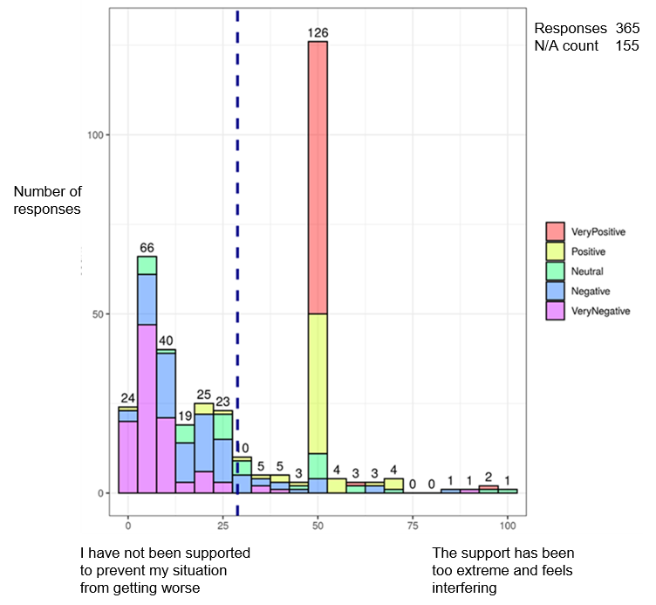
Figure 9: Responses to the statement ‘You have been supported to prevent your situation from getting worse’. Totals are demarcated according to how respondents felt about their story overall; dashed blue line indicates the mean response.
  - Stories in which the respondent felt they had not been supported to prevent their situation from getting worse often highlighted the speed at which a person’s circumstances can deteriorate without adequate intervention. A number of stories illustrated a lack of understanding or awareness about who to turn to when seeking support. In other instances, the stories describe situations where support was requested but not provided.

  - Across the stories there were examples of missed opportunities to provide support, not only to those who were specifically asking for it, but also to those who were in touch with services or providers for other reasons.

I got to the point where I couldn’t cope (with caring for my children) and did think about suicide - I had no family, no support. I viewed it as my responsibility and when I finally did ask for help there was nothing. My whole life was on show - you feel like a bad person for asking for help…

… We arranged an appointment and explained what we was going for, to then get there and be told, they couldn't help us. So told, go one way and then sent back to CAB (Citizens’ Advice Bureau). I took time off work for this meeting and it was supposed to help the situation but we was back to square one. When we met the shelter person he said he don't deal with housing issues like this- felt like a waste of time. He said we must have misunderstood, which we didn't as I said on the phone why we was coming. I was confused and disheartened as I told mammy why we was going and they would help us, felt I was fobbed off...

I am trying to get a diagnosis for a gynae condition that I have. The process has been going for years and I have been asked again and again about my mental health - my mental health isn't a problem, any problems I have with it are from not getting the right diagnosis and being treated as though I'm making it all up.

  - The impact for many is a toll on their mental health, as they attempt to cope with the deterioration of their own circumstances as well as those of their loved one.

… Apparently his dementia is not `serious` enough as yet, therefore we have to `just get on with things`, but there is not a day goes by that I come home and something or other has occurred which requires my attention to put right. For instance, he placed our electric cordless kettle on the hob to boil the other day, resulting in a near fire. I am so worried every day and feel so helpless and uninformed.

  - Some stories described services and approaches that actively offered support, or made themselves easily available to people. These stories were positive and demonstrate the value of services taking a more proactive approach to reaching people. They also demonstrate the importance of services that consistently and reliably provide low-level support, helping to build trust and create opportunities for people to ask for further support if needed, ultimately preventing someone’s circumstances from getting worse.

I get called every few weeks by the local carers group. They’re very good. At the moment me and my husband are okay. But he has memory issues and I've had some trouble with my hip - I'm not as active as I used to be. At some point we will need more help. At the moment it's okay, and because the group phone me I know I'll be able to tell them when the time comes.

Mentoring - I have been having mentoring support since around September. It is really good. Good to speak to someone, I feel like it has helped me. General chats about college, caring role and overall how I am. Feeling has benefited me. It is able to be done as and when, I know I have the option to have more if I need it. Overall I think it is great thing to have. Staff ensures work is done in college, helping my college progress.

I went to the GP with my mam and saw the carers centre banner. I wasn't going to do anything about it, but this was on one of mams good days, which she asked about the banner and was told someone from [organisation] was there is they wanted to talk. I felt this is going to be another false promise. I was too scared to hope, but when we went into the room I recognised the lady. Also was good as it’s the person who runs the project I would then end up accessing…There was support there if needed. It was a chance for respite and take mind off things.

… What I like about the young adult carers project is that they support you no matter what, even if a caring role ends. One day I knew the youth club was happening and I just turned up as did not want to set expectations that I would attend. It has taken me a long time to realise I do need support and I need to stop being isolated. I tried accessing other services that I thought would help, but they palmed me off or didn't have the right thing for me…Lots of professionals don't take me seriously but [name] who runs the YAC (young adult carer) project does. I am always taken seriously and never forgotten…

  - It is evident from a number of stories that creating opportunities to offer people support, and creating environments in which people can identify that they and / or their loved one may benefit from additional help, enables earlier interventions. In turn, this minimises the escalation of people’s support needs and assists people to maintain their independence.

Valuing Independence

  - Maintaining their own, or a loved one’s independence was a theme running through many of the narratives. The specifics of the support required to enable this varied from person to person and the stories provided examples of minimal interventions that made, or could have made, significant differences for people.

  - Stories highlighted the value of paying attention to the ordinary rituals of living, and what makes life meaningful for someone. Critically, they evidenced the need for people to be visible, respected and taken seriously.

I live in supported housing with three others. Mix of support workers - nine on the rota and I like them all. Once a fortnight I go out for a social thing. It's only me, which I like. I go on the bus, sometimes with a support worker. I always get to choose what I do.

I moved house at the end of October and had a flat built on my mother-in-law's house. There are about 30 steps to get into the flat - I applied to a charity for a grant towards a stair lift - on bad days or days when I need to go up and down them a lot it gets difficult. They said no, and that I had to go to the local authority - it is going to take 8 months for the local authority to come and see if I really need a stair lift.

I have arthritis in my hands and was finding things difficult where I lived - cooking was hard and things like hanging the laundry out. I wouldn’t necessarily have had a hot meal whereas here I can have one every day. I also look after my husband and here we get more care - really great help…

Now that I'm diagnosed with secondary progressive MS I only see the neurologist which is only once a year and I was feeling a bit lost (when the diagnosis was relapsing remitting I saw the MS Team more often). I felt like I'd been left in the void. I had their numbers but didn't like to get in touch. Then I had some health issues that were getting worse and rang them - I think I should have called them earlier because some of the issues had been going on for a couple of years - left a message and they called back the next day. I've now seen the MS nurse three times this year. I'm back in the fold now.

  - Examining responses to the question of whether people felt they had been able to discuss what mattered to them alongside responses to whether they felt they had been supported to prevent their situation from getting worse, a clear correlation emerges.

  - The central cluster indicates people who had been able to discuss what mattered to them and who also felt that they had been supported to prevent their situation from getting worse. The cluster in the bottom left indicates people who felt that they had not been able to discuss what mattered to them, and who also felt that they had not been supported to prevent their situation from getting worse.

Responses to the whether people had been able to discuss what mattered to them and whether they felt supported to prevent their situation from getting worse.
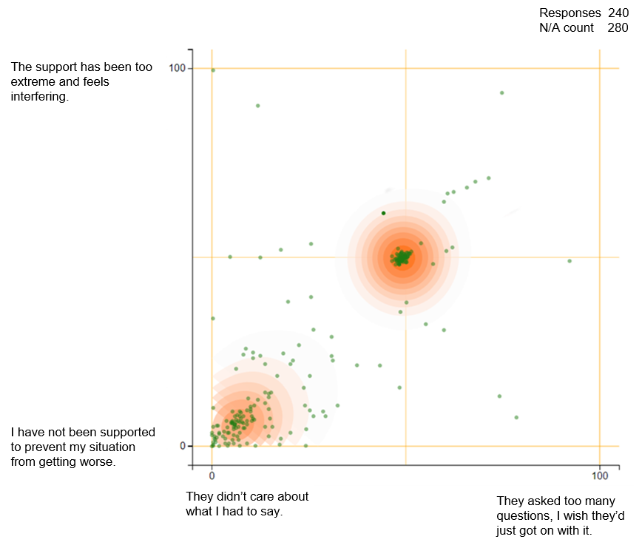
Figure 10: Correlation between people being able to discuss what mattered to them and feeling supported to prevent their situation from getting worse.

  - The stories convey the value of creating opportunities and environments in which people can talk about things that matter to them and where those things will be acted on (where applicable). This builds trust and mutual understanding and was seen to lead to the right support being provided, enabling people to enjoy independent living.

I heard about the centre through word of mouth, it was all very positive, and I was told that everyone knew what they were doing, and they do. When I was told I should come here I didn't feel too happy about it - I had to have operations to remove two blood clots from my brain and I didn't like the implications of needing to come to a memory group. But it’s been good to meet others who've been through similar things, and you only need to hint at an improvement and they're done - it’s a really good service… A lot of good rubs off from this place.

… I struggle to talk to people about how I feel. I keep things bottled in. Mum is physically disabled, I have autism, ADHD, dyslexia, Asperger’s, anxiety and depression...and a few more I can’t remember. Only about a year ago I was told about the Young Adult carers project as a friend of mine went to get support. Somehow we contacted [name] and met her and got the support I did need. It’s made a big difference - had other people to talk to, not just mum, can message [name] for support, less isolated, life became easier. Knew I wasn't alone and other people had same caring role. I enjoy youth club which has helped my mental health.

I fell last year in my flat. I was in hospital for 5 weeks. I have a new nervousness about going out now. I was glad to come home - I had a lovely welcome. I got back into the routine straightaway. Carers were very good - I needed someone in the flat while I showered, not in the room with me, just in the flat, just to be on the safe side until my confidence came back.

  - Respondents who felt they had been treated well in the story they shared, also very often felt they had received what they needed: positive experiences were seen to build trust in service providers. These experiences were often seen to lead to contact and communication that was immediately preventative and facilitated the provision of on-going support if needed.

Responses to people being treated well tracked across whether they got what they needed, had a choice and were listened to.
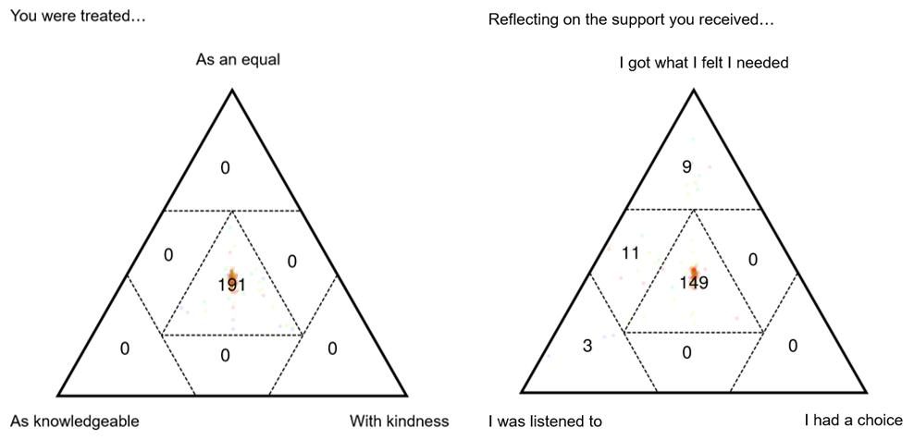
Figure 11: Responses where people were treated as an equal, with kindness and as knowledgeable, tracked across whether they got what they felt they needed, had a choice and were listened to. Numbers show total responses in that sector of the triad.
I volunteer through the local housing association - I used to be incredibly isolated and didn't leave the house, now I run a digital café…People keep an eye out for each other. The groups keeps me / others in a routine, it's not nice going somewhere unfamiliar - this has changed my life, a big impact on my well-being. I feel safe here, it's something to look forward to.

I have been coming to the gardening since last summer. I was referred by a local agency and introduced to the man who runs it. I'm learning to garden, it's a growing interest, and enjoy the small groups. I get to have a chat and have cups of tea. I've been watering the beans and the beetroot. I don't get out much other than this - it’s a lovely a group, really nice, I was made to feel welcome - nice and comfortable and relaxed, it's a good place.

  - Being treated well was a core thread in stories about independence and was associated with people feeling more confident and feeling safe and so happier to open up. Fundamental to many people’s stories were individuals and services that created space for people to discuss what was important to them and what independence meant to them.

Prevention – summary

  - There are an estimated 370,000 carers in Wales, who benefit the Welsh economy by over £8 billion annually through the caring responsibilities they undertake. Unpaid carers are the foundation on which many people’s support is built; ensuring the roles and responsibilities they take on are valued and properly recognised, must be fundamental to policies relating to prevention.

  - The themes which emerged from the stories in relation to the labour of care illustrate the lengths people will go to for their loved ones; they are demonstrative of the role a carer can play in preventing someone’s situation from getting worse and in supporting them to maintain their independence. Stories cited the importance of listening to and valuing input from unpaid carers and the consequences that ignoring them, or missing opportunities to provide support can have.

  - Enabling people to access and sustain independent living is a clearly stated purpose of preventative services, as outlined in the Social Services and Well-being (Wales) Act 2014. A change in someone’s circumstances, however, can happen very quickly and will likely take the individuals involved into uncharted territory.

  - The stories indicate that developing the skills and knowledge needed to navigate this change takes time, during which already vulnerable people’s situations have deteriorated further. Approaches that were noted in a number of stories as being valuable included creating environments in which people feel able to talk openly, really listening to people and engaging in more varied approaches to offering support, for example, through carers’ champions at GP surgeries.

  - Other stories identified that opportunities to meet with other people in similar situations, and build, informal support networks were highly valuable, as were the people and organisations that prioritised meeting individual, personal need. Overall, the positive stories reflected the importance of treating people well, on an individual basis that respected and worked with each person’s knowledge and experience.

Voice and control

  - Working from the premise stated in the Act that, ‘the adult is best placed to judge the adult’s well-being’ and that ’control over day to day life’ is a fundamental element of well-being, ensuring people have voice, choice and control, in relation to their care and support needs is a cornerstone of good service delivery. Enabling people to have choice in the decisions that affect them, should be a key driver in supporting people.

  - Across the narratives, four main themes emerged in relation to voice and control:

- People and processes
- The struggle
- Financial support
- Being person-centred.

People and processes

  - Thoughtful individuals and well-structured processes were seen to be the primary enablers in people having voice, choice and control in their experiences of using care and support services or being an unpaid carer.

  - Of the 520 stories that were submitted, 218 had an associated response to the question of whether the respondent had got what they felt they needed, been listened to and had a choice. 164 of those responses fell in the central zone where people felt that they had got all three of those things.

Responses where people felt they had got what they needed, had a choice and been listened to.
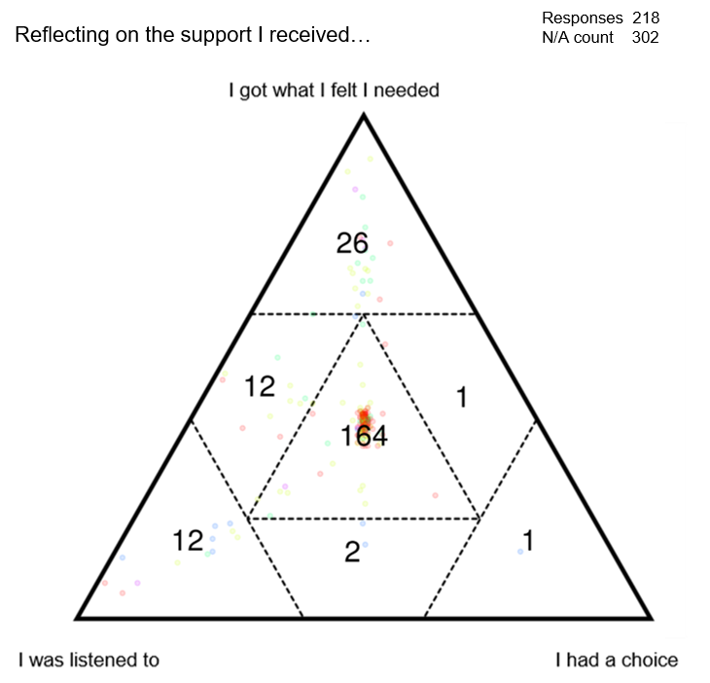
Figure 12: Responses where people felt they had got what they needed, were listened to and had a choice in the support they received. Numbers show total responses in that sector of the triad.

  - Across the positive stories were examples of professionals from within social care, healthcare and the third sector who delivered excellent support, responding specifically to the needs and wants of the individual they were working with.

  - In some cases, workers went the extra mile; however, many stories simply describe people being listened to, feeling valued and being taken seriously. It cannot be under-estimated how important these behaviours are to people. These stories highlight the incredible impact individual workers can have and the difference they make to people’s lives.

I am 17, I am in care. I would say that they are very supportive and I was able to tell [name], who runs the group about my college and University dream. She really helped me - she arranged work experience at the University on the days I am not in college, and set up a meeting to change my college course. My [organisation] workers said that they could help me too with the qualifications I need to get onto a different course. So I am doing The Prince's Trust with them now. Now I think I am on the right path and it has been because [name] at [organisation] has really helped me to sort it all out…

I had a GP, she was a fresh young GP and very good. She listened to me and was very person centred, she showed real empathy towards me and was highly respected. She made some referrals for me that lead to me getting the correct treatment I needed, if it wasn’t for her I don’t think I would have got the care I needed. What made her a great GP was she treated me with real respect and as an equal, I was never questioned or made to feel silly. She welcomed my ideas of what I thought was the problem.

I have carers in the morning - that’s been really good. She’s an absolute angel. Comes five mornings a week. This week she’s on holiday but she’s been preparing me for this for months. Didn’t know who would be there yesterday and different today - I have to explain everything and they can’t notice if anything has changed because they don’t know me. And although the first 5 pages in my folder are my care plan, no one reads it, they just sign it. Having [name] come every day makes such a difference.

I would be absolutely lost without him (my Personal Advisor). He’s always only a phone call away! He keeps his phone on all the time, He is truly amazing. He knows me as a person not just a client - he purposefully empowers me to make decisions, even when I struggle to make a decision... more than anything he is truly honest with me, especially with the difficult conversations and I really appreciate that. Other people might get annoyed but he just tells me how it is.

  - A number of stories described practical aspects of people’s lives and of the support services they use, and demonstrate the value of well-thought-through processes that prioritise the person being supported. They highlight relatively straightforward approaches to enabling the person being supported to feel and be more in control and illustrate the usefulness of approaches that consider the individual and their life more holistically.
We just had a hoist added in the living room and bedroom - it's one of the best things we've done and it was done very easily. They fitted both in one day and they've been fitted with no damage done to the house. The OT (Occupational Therapist) came out to look at whether we should have them and the decision was made straightaway.

I have an electric wheelchair which I now go out in every week. I didn’t used to use it, and one time when I used it, it nearly tipped over getting out of the building. Now we’ve found another way out, and also a back way that I will be able to use to get to my mum’s. Since my support worker has been encouraging me to use the chair and coming out with me I have more confidence. I’ll have an assessment at some point from an OT (Occupational Therapist) to confirm I’m okay / safe using the chair.

I use community carers' service - I love them, can't say a bad word about them. The team who I see are amazing. In a week I have 10.5 hours - most mornings it's the same person, apart from the weekend, and Monday, Tuesday, Thursday, Friday evenings I have the same person. And they send a rota so I know who to expect on Wednesday and at the weekend. Absolutely brilliant - always on time.

I care for my husband who had a stroke. Getting the bathroom redone - they (housing association) should be starting work the first week of December. They changing the false wall that's there, there's damp behind it, and putting in handrails - if he falls again he won't get up. There's no window so they're putting a fan in. He's got mobility issues and uses a frame at the moment but it slipped and he fell. It's been very easy - we had to wait awhile but I'm delighted to be a tenant with them - they're very good, they've done lots around the house, redid the doors for us, put a radiator in the airing cupboard, they fitted an outside socket to charge the scooter - you're not supposed to charge them indoors, they give off fumes. I'm delighted over this - the bathroom getting done - and so is he, he gets ratty if he can't do things by himself.

  - It was often seen that smaller things could bring about significant changes – people’s concerns related to the practical aspects of their own lives and the interactions they had with those around them. Good relationships with social care professionals, and those from related fields, coupled with processes that reduced hassle and built confidence in providers were seen across the positive stories.

The struggle
  - A thread running through many stories was the struggle that people experienced to get support: stories described experiences of individuals having no voice or control, and their struggle to be heard in decisions about their own, or their loved ones’ support. Words like ‘fight’, ‘battle’ and ‘struggle’ appear again and again in stories; while in many others, the experience may not be articulated so specifically but is clear nevertheless.

My son is transgender - he started school in September under his previous name and has since changed his name. He’s on the autistic spectrum… Everything is a battle - I did manage to get him into an LGBT support group but it’s an hour away and technically he’s too young for the group - they made an exception and I have to go with him. There are a lot of people with ASD in the group. He needs more social interaction and ideally closer to home.

I was caring for my mum who has severe mental health before she took her own life…When I asked the GP to put on mam’s notes that I am her carer - so all GPs or specialists would know I care for mam - he said 'nothing I can do'. It was always a battle for referrals to specialists, always just upping meds, rather than referring to specialists…

We're trying to fight for help with the paediatrician and the school - they are being helpful now. My daughter's going for statementing - I've had to push for this. She doesn't like loud noises. She was diagnosed with global delay by 12 months but that hasn't triggered anything. At 3 she was diagnosed with hyper-mobility. The OT (Occupational Therapist) gives her new insoles. The school is getting good at supporting her and adjusting what work they give her but she needs more support.

My daughter is peg-fed and this requires a very high level of hygiene. Getting the tube in the right place is complex and the nurse who should be training someone at the school to feed my daughter refuses to do so. She says the nursing guidelines say she cannot deliver this training, even though both the surgeon and consultant my daughter is under have said it’s fine. This means she cannot go to school. I want them to all speak to each other - I’m stuck in the middle, relaying information back and forth…

This is what’s happening and it’s not co-productive at all. I’ve questioned things and was told - this is how it is - I should try to fight it properly but I feel like I’m hitting a brick wall. I would fight if I knew how to. A lot of the time it’s like I’m burden. They try to be kind but it’s like I’m just a number they give money to - no personalisation. They don’t listen, they just tell you they can’t do anything about it - what’s the point talking to them?

  - Of the 520 stories that were submitted, 271 had an associated response on the negative triad, and 196 of those were in the centre. In these experiences, people, whether they were unpaid carers or the person being supported, felt that they had not got what they needed, not had a choice and not been listened to.
Responses where people felt they had not got what they needed, not had a choice and not been listened to.
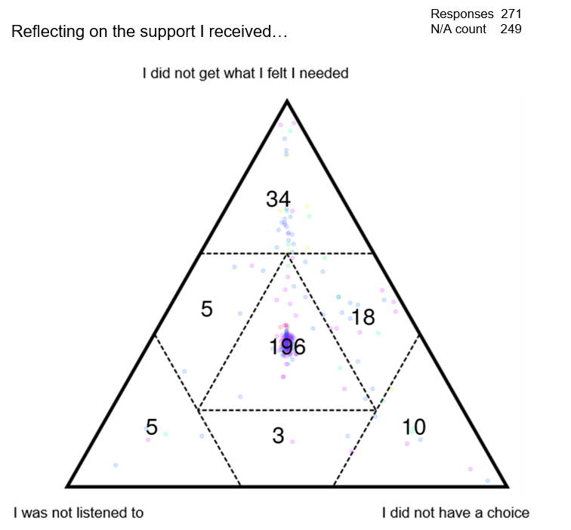
Figure 13: Responses where people felt they had not got what they needed, were not listened to and had not had a choice in the support they received. Numbers show total responses in that sector of the triad.
  - Many people described feeling out of control, caught up in circumstances that were out of their hands or ignored by people who should be listening to them. Very often these stories involved staff turnover, services that were under-resourced, gaps in services that should have been seamless, and consequent feelings of being deeply unsettled.

Just lost a grant that covered domestic help - someone is coming out next week to look at extending the current provision. In renegotiating the care package it may go back out to tender which could mean it moves to a different provider, that I’ll lose [name] (my current carer) and my current arrangements. I really don't want that but it seems to be out of my control.

He (from social services) said he would find someone to come and help [name] but I had to pay - it was £10 an hour and there was no means testing. That person was not reliable and missed a lot of appointments - she only came on and off and would send a text message or just not show up, which his really bad for my son, he likes routine. This all really troubles me, I’ve been very emotionally affected. I think she only came 3 times in the end - she came less and less and then just stopped showing up. It was really disappointing and I will not seek further support… It was a complete waste of time energy and emotion.

…I care for mammy but don't live with her. She has fibromyalgia. She is in a big mess with housing and money and I have had to step in to support her. I arranged mammy to have tenancy support as I couldn’t help with the whole house and debt situation on my own. So [organisation] got involved to give mammy support, or that’s what they are supposed to do. Since they started [organisation] keep giving us false hope and causing mammy and me to have breakdowns. This is because since October 2019 to March 2020 she had has 4 support workers.

  - Many stories described individuals needing to be very active in the pursuit of support – phoning providers, chasing appointments, following up on meetings – and the impact that those efforts had, particularly when they went unanswered. The toll that waiting, be it for responses, information or support, took on people was significant, impacting their physical and mental well-being.

Our children are not the problem. The problem is all the form filling and dealing with the local authority. We spend most of our lives meeting with people and explaining ourselves.

In November my YAC (young adult carer) support worker chased up the referral as we hadn’t heard anything but they had no record of it so my support worker put through a new referral. Within a couple of weeks lifeline put everything in place and were great and then they chased up social services and occupational health again. Social services phoned a few days before Xmas to introduce themselves and find out what we needed as they could only deal with emergency cases so said they would contact us again after Christmas but it is now nearly March and we haven’t heard anything. All we have had is a bulky form to fill in about finance with no offer of help to do this.

I have chronic pain conditions; 14 months ago I saw the psychologist from the [city] pain team to discuss traumatic experiences suffered a few years ago. I explained all to her - she was shocked and agreed that what I'd endured was horrific and that I needed psychological input to get over it and prevent further escalation of the mental health impact. Since then I've heard nothing apart from when I've chased it up. I've been assured that I've not been forgotten but still no appointment and no help. I was also upset to find that they things I'd expressed in confidence were then shared with my GP in huge amounts of detail which I hadn't wanted.

My son was independently assessed earlier in the autumn but we still haven't seen the report from this. It has gone to the local authority, apparently, but we haven't see the paperwork yet. I had assumed it would come to us at the same time as going to the local authority - I've been chasing it up but still don't have a clear answer.

  - In response to these challenges, and the need to be persistent in seeking support, a number of stories described being pushy and insistent, adopting specific strategies and attitudes to secure the support that was required. Often these behaviours were ones that the respondent said they would have preferred not to have needed to adopt, or they voiced concern that others may not be able to adopt them and so would be left unsupported.

I have three daughters, two of whom are disabled. My youngest is well supported because I have demanded it - it's because I shout a lot. I'm gobby so I've asked for things. Getting the right support for my middle daughter has been harder - she has a brain injury. I had a carers’ assessment a little while ago - the person who did it was very nice, said lots of things and asked questions, but none of it was relevant.

…My husband solely relies on me - we're getting a care package for the morning before we hit a crisis - still waiting for the initial consultation though. I've got more chops than a butcher's shop so I'll keep on at them. The discharge nurse was very good - she told me to think about the future in terms of what we needed - everything I needed to know was via word of mouth - she made clear she'd get in touch with someone and make a referral and social services called the next day.

It was a year ago this week that I finally had to leave my role as a carer to others. But I have two significant and costly lessons to pass on from that period: Make sure you have power of attorney and think carefully, and probably locally, if a stair lift is needed. I had been battling for months with my wife's increasing dementia and mobility problems and getting her safely up and down stairs had become a daily nightmare with the danger of us both falling from top to bottom…A nurse who had looked after my wife along with others for nearly two months gave me the best advice: The ones who shout the loudest get the most. Make sure your loved one's voice is heard.

  - Among the stories from those who had not got what they needed, had not been listened to and had not had a choice, were those that described administrative decisions or processes that had significant detrimental effects on people. They demonstrate the cognitive and experiential gap that appears to exist in a number of stories between those that provide or make decisions about services, and those that should be benefiting from those services. They indicate the need to engage with, listen to and respond better to communities and individuals, and allude to the knock-on effects of not doing so.

They've changed our bin bags so we have to put incontinence pads in a different bag - it's bright purple and really thin so everyone can see what's inside. It’s ridiculous and embarrassing. I don't want people to see our rubbish or know that one of us has to use incontinence pads.

Used to receive weekly schedule of who to expect. Had two male names one week - no one had asked me if I was okay with that. I rang and said ‘no’ and now I’m down for female only. My care is personal care so I’m surprised men would have been rota’d on. Now I don’t get the rotas but I know there won’t be men on it…

My carers do not come at the same time every day and I am not informed about this. This lack of communication makes my life uncomfortable and difficult. I need to know when they will be calling in order to organise my personal needs. In emergencies there is no contact to liaise with. Difficult to contact the local authority to improve my life when promises are made but not followed up on. To get what I need I always have to be the one to follow up. I do not like being patronised which I feel I often am when in contact with social services.

  - Reducing the struggle that many people experience when seeking care and support services should be a priority. The stories indicated that the burden placed on people originated from a number of sources and added challenge and complexity to circumstances that were already difficult. A number of the stories described administrative processes that added to people’s struggle but that may offer comparatively straightforward places for organisations to start improving people’s experiences.

Financial support

  - Having voice and control, and the choices that would often follow, are linked to the means by which they can be achieved. Financial support, therefore, is a significant factor in many people’s experiences and their capacity to feel in control.

  - Finance was a theme that arose in a number of stories, and 72 stories were more specifically about financial support. Of those, 67% were negative or very negative. Stories that related to direct payments and Personal Independence Payments (PIP) were notable in their descriptions of confusion and people struggling to get the right support.

  - Direct payments were a common theme in many of the stories. People’s experiences were varied but described how positive using direct payments could be. The confusion that still surrounds them and the frequent lack of clear information or guidance about eligibility or application processes however, was a source of frustration. The role of ‘employer’ was one that, for some, was quite uncomfortable or unwanted.

I was told about direct payments right at the start - she said it but never explained it. People can apply for the job - not that I would be in control of things. So much language and terminology I didn’t understand and that was chucked at me…if someone who uses continuing healthcare or direct payments had explained how they used them I could have understood…

I've got two brothers with learning difficulties and my other brothers work in LD…I moved back to the area and moving in with mum and two of my brothers made sense for all of us. They get a bit of support through direct payments which mum manages, although becoming an employer in her 70s wasn't necessarily what she wanted. Through [organisation] they've got lots going on, their weeks are filled with doing stuff with their friends - mum does full time care and is very active. The concern is when she is older or less able to cope.

…My older son gets direct payments to be [name]’s PA for up to 10 hours a week. I was not aware that this was possible until a care co-ordinator told us - I refused initially because it’s his brother. You find out things from other people. Coming here has been a blessing, and seeing other parents. This allows me to have a bit of break. My husband and I haven’t been out alone since he was born.

I am the parent of a child with ASD. A few years ago, nobody in my network knew about Direct Payments for example. We were given no information then. In recent times awareness is beginning to improve, as a result of parents linking together and also through social media, rather than what we hear about through social services…

I employ my own agency using direct payments that come from the local authority but there are fees that come with an agency and I don’t know if these are covered. I’ve been with the same agency for 9 years and I don’t want to change that but I don’t know if the costs will be deemed to be eligible. I used to be able to use my funds towards my carers’ travel costs but now that the WILG (Welsh Independent Living Grant) is with the local authority I don’t know if this is covered by social services now so I may need to pay on top of this.

  - PIP is a form of support that should promote and enable more independent living; however, stories suggest that the application and assessment processes create incredible strain for the individuals applying for it. Overwhelmingly, stories about PIP were negative and highlighted the trauma many respondents felt at going through the assessment process.

I have applied for PIP - it took me a while, I got the paperwork but couldn’t face it so it expired. Then I got it again and [name] from our group supported me to fill it in. That was 6 months ago - I have no idea when it’ll get done, I’m assuming it will be rejected. It’s distressing and daunting, like it’s set up to be against you. You haven’t got the energy to fight it, it’s degrading, it’s like you’re asking for the world.

Going through the PIP process was awful. It makes you feel inadequate - you lose confidence in yourself, feel like you're not believed - it's like you're on trial and being scrutinised. I felt really humiliated. I had to go to my GP and ask for copies of everything - we're not told these things, that we should keep things, find it out by chance, or when you're going through the process when everything is really stressful anyway.
PIP is one of the most horrendous things I've been through - the questions, the things they wanted me to do, like touch my toes... I refused because I would have fallen over. They come in to your home. I've learnt now that you've got to keep all the letters you ever get in case you need them for this sort of thing. They're going to review me again very soon even though I've got a progressive condition. It makes no sense. And the stress and the worry and the anxiety of it all.

  - Well administered financial support was seen to offer a means for people to manage their own support, promoting independence and enabling people to reduce their reliance on third-parties. Clearer information, and processes designed with the individual in mind, would improve people’s access to financial support, enable more comprehensively person-centred support and reduce the confusion described in a number of stories.

Being person-centred
  - Providing support that meets the specific needs of each individual should be the focus of care and support service delivery as outlined in the Social Services and Well-being (Wales) Act 2014. Ensuring people have voice, choice and control in decisions about their support is fundamental to this. In principle, the Act legislates for whole-person, needs-led support that is guided by the individual and tailored to their specific needs, identified in conjunction with them.

  - Despite this, a number of stories described process-led support that failed to meet people’s needs. Often these stories outlined the need for an individual to fit in with the support being provided rather than the support being designed to fit around them. A lack of consideration for the wider needs of a person was often seen to prevent participation in activities that would contribute to well-being and positive mental and physical health.

When the local authority assessed my hours I had to write a day plan of what each hour would be for and to justify and explain every hour. I’ve been assessed as needing 53.75 hours week - getting up takes an hour and bowel care takes 1.5 hours every day - that’s a third of those hours gone. Socialisation is really important to me. When I’m out and about I feel happy - this isn’t seen as important, it’s not valued…I’m constantly trying to work out how much I can fit in with the time I’ve got. If I want to do anything extra - go out for my birthday, for example, I’ve got to work all the hours out to make sure I’ve got enough.

My son’s weekly regime of Pilates and aqua-aerobics contributes to healthy movement and supports his mobility - exercising in water is particularly beneficial. He has previously also been a regular attendee at [organisation] but that has now closed. We arranged a gym membership for him - this is by far and away the most cost-effective way of him getting the exercise he needs at the frequency that he needs. This is now being queried and we’ve been told to source alternative options, for free - no such options exist. Any alternative would be far more expensive. We’ve also been able to negotiate with the gym so that his PA goes in with him for free. In addition to the physical activity, these sessions provide him with social interaction by being part of a community group which accepts and supports him as a valued and welcomed member. I find it difficult to understand why an Act claiming to address people’s well-being would lead to attempts to deny these kinds of inputs which have been built into my son’s carefully monitored and successful support plan.

I am a lady in my mid-thirties. I suffer from Down syndrome and am registered blind and deaf. I am non-verbal and use a wheelchair. I also have learning difficulties. People often talk about me rather than too me and presume that because I am non-verbal I do not / cannot be included in a conversation even when it relates to me. I have an AAC app on my iPad for communication but require support to learn and maintain my use. Some of my support staff will use it, but many others won’t, so I often do not get the chance to make my own decisions and speak up. Because my behaviours are sometimes challenging, my iPad is used as a punishment and not given to me. Staff also place me in a low stimulation environment, which further restricts my ability to interact with others. As a result I get extremely frustrated which is often misinterpreted as challenging behaviour. Someone please take notice of me.

  - Being truly person-centred requires flexibility and discretion in decision-making; people’s needs are not static and care and support should accommodate this. Respondents who shared stories about fluctuating conditions, and chronic, sometimes progressive conditions, highlighted the challenges they faced when seeking appropriate support. A number of stories also highlighted the difficulty people face when they know they are unwell, or in need of support, but do not have a formal diagnosis.

...As it is only me and mum that live at home, I am her main support. She has tried to get help from health professionals, but she is always brushed off with sentences such as do more exercise something that she cannot physically do under her chronic fatigue. This limits her quality of life and makes her feel alone and isolated as she rarely get to go outside because she is too tired and weak. I would really like to see her get the help and support that she so desperately needs.

I have some mental health problems. They’re very variable and some days I really need some help. Also there are things I would like to do but I can't and would need help or someone with me. I was told about direct payments, they sound really good. I'm confused about the assessment process though. Especially because my situation varies. It sounds like they can assess over a long period, months maybe bit I don't really know how that would work.

My daughter has periodic mental health issues and I suffer from occasional depression myself. I find it very difficult to get the support I need because it doesn’t happen all the time. I am a low income parent in my early fifties and my parents are also in need of care. The best support I get is from community groups. They provide understanding and companionship when I am lonely

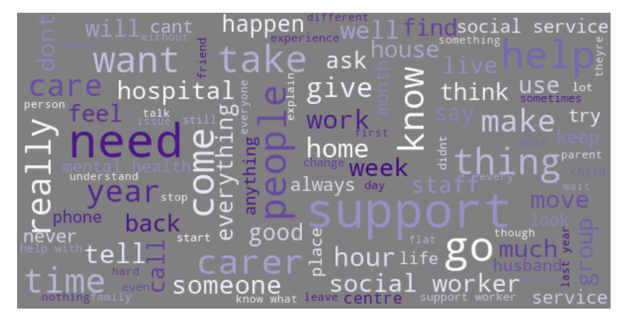
Figure 14: Word cloud generated from the stories of people who said they were disabled.

  - Some stories contained examples of people who wanted to live fulfilled, busy lives but who were reliant on care and support services to enable this. Stories revealed the challenges people faced when seeking support that would address all of their needs and enable them to live the life that they wanted. For example, people were housed inappropriately, were unable to engage in activities they enjoyed and wanted to work or learn but were unable to do so.

I moved house recently. The house I was in became unsuitable and I approached my housing association about moving. They offered me a house that was accessible itself but its location was really poor - I would have been really isolated as there's no transport links, no pavements (I use a wheelchair) and no shops nearby and the house was up a hill. I turned it down explaining why and the person I spoke to said 'I'm really disappointed you've turned this down'. Not everyone would be comfortable saying no to something and this kind of attitude doesn't help that. I have now moved to somewhere much more suitable that I like and which is close to transport routes, shops and pubs...

…She moved into a supported living complex but the bulk of it wasn't wheel chair accessible so she was effectively in solitary confinement. In the end, a friend of mine paid for my daughter to have physical therapy privately and after just two weeks she was up and about again and can walk short distances, this was after four years of nothing on the NHS.

For the last couple of years adults with severe learning difficulties who are deemed incapable of making significant progress have been denied access to adult education by those in government be it local or national. My son loved the routine and structure of his adult education classes and whilst he was struggling to progress, these classes helped him retain all he had learnt over the years. It has been about 2 years since he was forced to leave his course at [college] and they have been miserable for him and made my life as a carer harder. His loss of routine caused behaviour problems which he had never had before, mood swings resulting in periods of uncontrollable crying and withdrawal from us and other activities. Instead of denying those who need the most help from attending literacy and numeracy classes, the local authorities should arrange classes that those we care for can access & which take into account their severe learning difficulties.

There should be more support to go out in the evening. I only go out in the evening every two weeks unless there is a party. Mum and dad don't want me to go out after dark by myself unless I'm in a taxi and that is expensive. After 8pm there is no one to come home with me - I can see why mum and dad worry but I would like to do more in the evening so I don't feel so lonely sitting in my annex by myself.

…I am deaf and have learning difficulties and my mum looks after me. She wants a carer but she can’t find anyone to look after me. I have been looking for work since 2005. The Job Centre is no help. I go in and they call my name on the tannoy. I can’t hear it! Sometimes when they talk to me they look the other way so I can’t read their lips. Or they cover their mouth. The worst is when they chew gum when they are talking to me. They never have an interpreter or anyone who can sign at the Job Centre so my mum has to come with me all the time. She gets annoyed by that. I really want a job. Just one on a shop floor, stacking shelves, not on the till or anything like that. I would love to earn my own money. I am trying to get a house but I need a job first. I did try voluntary work in a charity shop but I got no support afterward. I never get interviews, and they never let me know about the jobs I could do. There are lots of emails and texts telling me to read my emails but it’s too much. I feel let down all the time. The college let me down. The Job Centre let me down. [Organisation] let me down.

  - In contrast, a number of the positive stories described interventions and experiences that might be perceived as unremarkable. Nevertheless, these were important and illustrate many of the relatively straightforward approaches that make a difference for people. People talked about being able to undertake activities they enjoy, about knowing who would be coming into their home each day and having good relationships with those people, and about the value of personal approaches and support.

I lived with mum for 34 years and wanted to live independently. Mum did everything so I wasn’t really known to social services. Now I live in my own flat, not far from mum, with personal care support for an hour in the morning and half an hour in the evening. I also have six hours a week, normally in one day, support for shopping, cooking and other things. I get housing support through [organisation] - they help with the admin of having a house and with forms and things. They call me or I call them if I need anything - apart from PIP, I’ve been fine with everything.

I have carers come in every morning and my wife does the care on the weekends so we can have a lie in, and also in the evening. Generally it's the same carers every day and I get on okay with them. Sometimes I haven't liked someone and I've requested they not come again and that's been fine. They're very good, I can communicate well with them. They're local authority carers so there's always back up if someone is off. I get a rota the week before so I know who to expect. I insisted on that at the beginning and they were fine with that. They do it for those that request it but not otherwise.

We have a carer come in in the morning for an hour - they work at her speed, it’s about helping not forcing. It’s the same company and seven or eight carers that we see. About a year ago the local authority changed our provider and that was a massive improvement. They only do 1 hour appointments when we used to only have 30 minutes. In the last twelve months her care and well-being has come on leaps and bounds. [Name] from [organisation] comes for two hours on a Thursday lunchtime and they go out together in nice weather. She’s seen huge improvements in the last 12 months as well. We’ve got used to each other – I’m more relaxed - the last 12 months have been amazing, the new carers get on so well.

I work in a cafe. I started a little while ago. I am the chef. I cook everything with the help of the staff. I had some training. My support worker asked me what I wanted to do in the day time, and I said cooking. I am asked what I want to do now in my day time activities rather than being told what I am going to be doing. It is better now because it is interesting. I do some cooking at home now too and I go to a cooking class. I like eating different things now. When I see my support worker they ask me how it is going and if I’m happy. I do more different things than I used to, which I like.

I always see the same 2 carers so I’ve got to know them. They do shopping for me, they don’t have to but they know it’s useful to me. I can’t cross the main road in my wheelchair.

There should be much more advocacy - they have time to support people in a more personal way, to support them in a way that’s important to them. [Organisation] are great for me - their work is great, they should get more funding, they’re better than social services - more personal, more understanding and they’ve got more time. They’re helping me with trying to move.

  - Delivering person-centred care need not be complicated. For many people who shared their story, the behaviours and actions that stood out, or made the difference, were simple and straightforward. They were important because they were personal, they responded to the specific needs of the individuals being supported, and they reflected that people had been listened to and heard.

Voice and control – summary
  - The Social Services and Well-being (Wales) Act 2014 clearly states that those who exercise functions under the Act must have regard for the individual’s views, wishes and feelings and must have regard for the importance of providing appropriate support to enable them to participate in decisions that affect them.

  - That the adult is best placed to judge the adult’s well-being, is similarly clearly stated, and in a number of stories, the value of this was demonstrated by workers who engaged meaningfully with those they supported, listening to them and working with them to act on those conversations.

  - While being person-centred is not a new notion, at times in the stories it was seen to mean services that revolved around a person without agency, rather than being services that worked with that person and delivered holistic, needs-led support.

  - The struggle that many people described was significantly reduced by thoughtful processes and attention to the detail that mattered to people. Often these were administrative issues in relation to who was coming into a home or whether financial support could be secured easily.

  - Reliability and consistency to services and individuals promoted people feeling in control of their own circumstances, ameliorating many of the frustrations people expressed elsewhere when seeking support or guidance. Similarly, ensuring people’s access to support services is as straightforward as possible and minimises an individual’s need to be pushy was described by number of stories to be valuable and set the scene for more positive, on-going interactions.

  - Critical to a number of the stories was the importance of supporting people’s lives in a well-rounded way, enabling them to engage with a variety of activities and address all aspects of their well-being in ways that suited them.

Multi-agency working

  - The provision of ‘seamless’ services is a key element of health and social care policy in Wales. The Social Services and Well-being (Wales) Act 2014 makes specific statements in relation to co-operation and partnership, as well as about the relevant partners a local authority may be expected to work with. The experiences of many people who shared stories related to multi-agency working, indicate that work remains to be done on ensuring that services are seamless.

  - This section will specifically discuss two key themes that arose from these stories and that highlight critical factors in relation to multi-agency working:

- Seamless services
- Transition and change.

Seamless services
  - When asked to think about the story they had just shared and consider if the different services and providers had worked together well, 26% of respondents agreed that they had, while 59% disagreed.
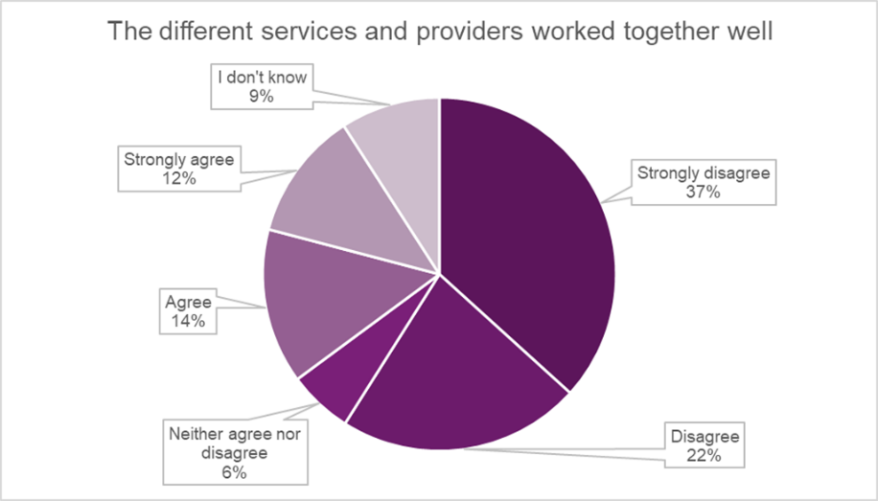
Figure 15: Breakdown of responses to the statement ‘The different services and providers worked together well’. Response total 373, n/a count 147.

  - When responses to this question are considered alongside how people felt about their story overall, a clear correlation emerges. People who felt that services had not worked together well were much more likely to feel negatively about their experience. Developing approaches to co-operation and reducing the gaps between services is of demonstrable value and would lead to more people having positive experiences. 75% of respondents who strongly agreed that services had worked together well felt very positive about their story overall.
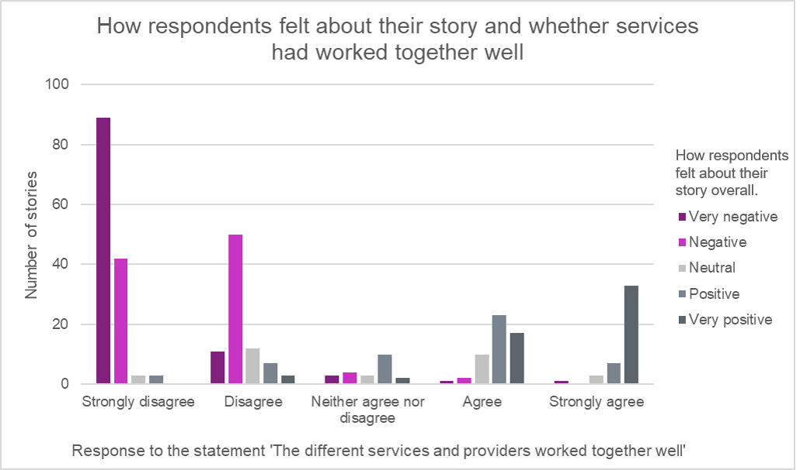
Figure 16: Responses to how people felt about their experience grouped against whether they felt the different services and providers had worked together well. Response total 339, n/a or ‘I don’t know’ count 18.

  - For many, navigating the complexity of working with multiple services or across sectors was extremely difficult and one of the biggest sources of frustration and upset.

…My sister had been going downhill for years but got a diagnosis 2 years ago. Initially she had a fall and was admitted to a care home straight away. This has made her so anti care home that she is determined to stay in her own home. It’s a minefield and even though I work in the system I don’t know how to get help. Departments don’t talk to each other and my sister has to explain her condition repeatedly to everyone she comes into contact with.

  - The need to repeat information to each new provider, worker or service was a recurring theme. It was associated with frustration and negative impacts on people’s mental health and emotional well-being, as well as with individuals becoming more disengaged from service providers.

The memory clinic, Parkinson's clinic, hearing clinic and eye clinic are all separate - not connected at all. It would be much better to see them all at once. And I see so many GPs who don't know me - I'm always explaining myself which is very stressful.

I had a PIP assessment last week and it was okay but I had to go through everything again. Since all of this began, at every step I have to go through everything again. Traumatic conversations need to be repeated again and again. And there's no guarantee about anything. It makes me feel that no-one takes mental health seriously. And when you've repeated everything then you're still waiting, everything is about waiting.

All I want now is 2 full time people then I’d be sorted, I’d be able to just crack on. I don’t really need any other help and wouldn’t really need a social workers. With 2 people I’d have cover for leave and sickness from someone I already know really well, and when they were both working I’d have time to go do things and be active. I’ve asked the agency to send the same person as much as possible - I’m sick of the sound of my voice needing to repeat the same thing – I’ve got to live my life with this disability and I don’t want to be talking about it all the time, repeating myself.

  - Assessment processes that should support multi-agency working and provide more cohesive and co-ordinated provision for people, were felt by some to be inadequate or poorly delivered, focusing on the wrong elements of an individual’s life.

I care for my mum - which I can't do 24 / 7, I have spinal problems. My mum is in the hospital at the moment - they won't discharge her until there is care in place. But because I'll be having an operation myself we need something drastic. I've been trying to talk to the nurses about this but it's so difficult. I know she needs support. An assessment is going to happen, I think the hospital have arranged this, but I don't know exactly and I don't know when it's for. They're not telling me much, I don't know that I'm getting anywhere with them. They asked if I was happy for mum to come home, which I am, but we need support - I can't support her myself - they're asking the wrong question. It's worrying knowing that I'm going into hospital and no-one is there for my mum.

The report we received in relation to my son’s review indicated that only 4 of the 8 categories that contribute to well-being had been considered…They’ve cherry-picked the easiest options. I have refused to sign the assessment off and that’s where we’re hovering now - where we have been hovering since last summer. This is ongoing - really stressful for all of us. I’ve made clear that I will challenge any removal of support so they drop back and then every few weeks they get back in touch saying things need to move forward, progress needs to be made etc. it just keeps going round - they keep us dangling. My stomach churns every time an official looking letter came. I dread picking the post up. They now want a health team brought into do an assessment. They haven’t explained why they want this - we don’t have a relationship with them, there’s a real lack of trust. It makes me feel like we could be being led into a trap.

  - Transport emerged as a key concern in a number of stories with narratives describing bus routes that had ceased running, community transport with dwindling numbers of drivers and the challenge of getting to and from places. They illustrated the impact that poor transport has on day-to-day living, people’s well-being and their capacity to engage with useful services and meaningful activities. Significantly they demonstrate the very practical issues that arise when transport is not considered as part of seamless service delivery.

I always use hospital transport with my mum - they never pick us up on time and then we have to wait hours and hours to go home. I have to go to hospital next week - because I went on a trip last week I have support hours saved up to put towards going to the hospital and the extra hours the long day / using the transport will need.

After I had my op I couldn't get up the stairs and we had an annex built for me - got my bed, my telly, my stereo in there, and there's a wet room. I come here (local group) three days a week. Mum and dad bring me. Used to get community transport until they stopped it.

Among the things they want to stop funding are transport costs and his gym membership. We live in a rural area, not on a bus route - support staff would be out of pocket straightaway, not funding transport is really detrimental. There is very little offered in [local authority] - you have to find it for yourself, or you have to create it yourself. My son’s friends have had their funds cut - they’ve lost PAs or can’t cover the transport costs to get to things. The people who we would normally see at events and activities aren’t there, or they have to leave early to fit in with staffing patterns. There is a weekly disco that he goes to and half the people leave at 8pm - they’re in their 30s but there’s a shift change at 9 they have to be back for. So although he can get to activities at the moment, there are fewer people for him to socialise with at them.

  - Beyond the stories about transport were a number that described obstacles, both physical and administrative, that hampered people getting from their home to other places. These obstacles impacted not only on people’s capacity to leave home, but also their confidence about doing so, their capacity to engage with support and their necessary, but often unwelcome reliance on others.

  - Of particular note were the stories told primarily by wheelchair users and older people with walking difficulties, about pavements being obstructed and about people’s ability to acquire or renew a Blue Badge.

I can't go out on my own because I can't guarantee a good route - pavements are blocked, people are parked on dropped kerbs. I have to stay in or wait until I can go out with someone else.

I have had a blue badge since 2013 which I have to renew every 3 years. I'm not on DLA so I have to provide proof of disability as well as proof of address etc. I don't have these things - my MS diagnosis is historic - they ask questions like 'when did you last see your GP for this?' - I don't see the consultant and don't see my GP for my MS - there's no need. I hate forms and I don't understand why this is so difficult especially when I'm just renewing.

  - While these matters may be seen to fall outside the immediate purview of care and support services, they are central to people’s ability to engage with services. These stories highlight the need to think broadly and completely about what really matters to people and the practicalities of supporting people to achieve that.

Transition and change

  - Across the narratives were numerous examples of transition and change in a range of settings and circumstances. For example, people described moving from health to social care services and back again; from being well to having a terminal diagnosis; from being a partner to being a carer; from children’s to adult services; and from being a carer to being bereaved.

  - Many of these stories described difficulties inherent to periods of change and transition and these flashpoints in people’s experiences reveal missed opportunities to provide better, more continuous support.

My partner was my carer - she became ill and went into a home where she died. Although it was known that she cared for me nothing was put into place for me. When she died I was sent a condolences card but that was it. Now I'm being pushed from pillar to post trying to get the help that I need…

…I feel helpless as she deserves to have the most amazing life doing whatever she chooses to do, but I can’t provide it myself. There is nothing in place and [name] finishes in three months. If we lived in Cardiff I know it would be different, but there is nothing in our locality. There are many young people in this area who are in the same boat. This is their community. I’m still waiting for an updated carers’ assessment, which is outstanding. [Name] needs support, twenty four seven, and throughout our time with Children’s Services we had no concerns, there was always support and activities on offer. Now there is not even a youth club, there is absolutely nothing to do in the evening…

Our issues really started when my daughter was seventeen during the period of transition from Children’s to Adult Services. Change is difficult for my daughter who is on the autism spectrum. Our experiences with Children’s Services were good, as my daughter established a relationship with her social worker and trusted her. However we were surprised when she moved to Adult Services that no information was shared from the extensive information that Children's Services held. Our first point of contact was when someone came to our house and wanted to know all about her background, even though all the information was readily available….This whole situation feels like it has become personal with a particular Social Worker, purely because I have challenged the way they have behaved towards my daughter. As a result I’m so worried about my daughter’s future. Are they going to take it out on her? Unfortunately I do not know the answer to that. To date we are still going through the motions and my daughter’s future remains uncertain.

  - Providing the right support to people during times of transition was often seen to be complex but highly rewarding, making significant difference to people’s lives and their futures. The interpersonal relationships between people in need of support and people providing support appeared critical to positive experiences of transition.

Mum (who I had been caring for) went in on a Monday and died the Tuesday…They spoke to me calmly and quietly whilst having a cuppa and explained what would need to happen next and they would help me. I was supported to see [name] the benefits officer and also I was given a social worker too as I couldn’t manage without one. They helped set all this up for me as I couldn’t do it alone… They prevented me from having nothing....which if I was along would have happened. I was only 18 so still a child at the time in a way. I hadn't grown up in some ways that others would have. I wouldn't have what I have now without them.

After 6 months in hospital, my mum aged 93, along with the family, needed to decide on next steps and started the very complex process of looking at options for support following her hospital discharge. As a very independent lady she was opposed to having carers coming into her home with a key safe and not knowing who would be waking her up or putting her to bed. After 5 months of 4 carers a day and some initial erratic incidents she has settled into the new regime and considers the carers to be kind and patient…

I had a nasty fall just before Christmas and broke my arm in three places which also meant I couldn’t use my walker. I was in hospital in [town A] and then [town B] but I live in [town C] and that’s where my friends and family are. The health board were just going to keep me in hospital / rehab for weeks. I wanted to go home and I was really worried about my tenancy…[name] worked really hard and managed to put things in place so I could home from hospital - it was a bit intense, everyone was working really closely together to provide 18 hours of cover that I needed…

  - A notable theme to emerge from the stories was that of determining whether support needs should be met by social care or by the NHS. Identifying who should be paying for services was a consistently difficult issue for the person being supported, and one that distracted from, and delayed, the support being provided.

  - Whilst finance is a core component of social care delivery it should not be the focus, nor should administrative processes that surround it interfere with people being supported. For most people, the debate about whether needs were health needs or social care needs bore little relationship to any change in their circumstances that they could identify.

When nurses did my bowel care it was paid for. But I didn’t like this - it was invasive and unpleasant, so I got a new system that my PA can do now that she’s been trained, but this isn’t covered because she’s not a nurse. It was going to be covered but when the area moved into [health board area] they then changed their minds. When the nurses came I had to organise myself around them and when they could come…Now we can do it when it suits us – I’ve not had one accident since September whereas I was having them all the time but the time isn't covered as part of my care package.

…I was left to pick up the bill for caring for a lady who could not walk, feed herself and whose voice and reason was disappearing. A letter informed me it was my choice to move her. I was moving her into the care of friends in [local authority] and [original local authority] were lightening quick to wash their hands and wave me goodbye. It took from September 2018 to February 2019 before another CHC (continuing healthcare) assessment was made. Staff at the home were amazed she had not been brought in under CHC but the February assessment meant no more bills and NHS care. It had cost around £17,000 with care home fees plus a £2,000 chair that I purchased that was also of no use when she became permanently bed-ridden… As a result I have had to submit a claim for the return of care home fees and any reimbursement can only be claimed after my wife passes away

I live independently with support from a PA funded through continuing healthcare. I get very good, individualised support for between 5 and 7 hours a day. The support I have now is very good but getting to this point was difficult with too few hours, attempts to move me from CHC to receiving direct payments which would not have provided the support I need, and issues like learning to use a spoon and being told I had improved and so had my benefits cut. We've had to push for everything I've got and now my PA can do everything that I need and if I move at some point I can keep the same PA.

  - Regional Partnership Boards (RPBs) were established under Part 9 of the Social Services and Well-being (Wales) Act 2014 and they are a core mechanism for facilitating integrated services and for improving health and well-being outcomes. Fundamental to the functioning of RPBs is their broad membership, including citizen and unpaid carer representatives. Issues persist however, in parts of the country at least, in how these structures function, how their role and activity is communicated and the public’s perception of them.

The problem is communication and lack of it, a failure of many organisations like Partnership boards to address this or put effective mechanisms in place so ordinary members of the public can approach them. They’ve created an elite body that people often, in my experience, haven’t even heard of. They’ve placed a lot of reliance on technology and forgotten that a lot of us don’t have the internet, and even if they do, they need pre-knowledge of an organisation - they’re unlikely to come across it by fluke. This doesn’t seem to be understood by these organisations. I’m very, very angry. Regional Partnership Boards should have a duty of responsibility and accountability to the public, yet they make it almost impossible to contact them. There’s almost a strategic purpose in ignoring people and their communiques. There are clear failures in bringing about equality with health and social care. I’ve been fighting this battle for over 50 years, waiting for true integration and equality of esteem in the two sectors. Lots of fine words and promises about how this will happen and then nothing does.

  - In periods of transition, the gap between services is perhaps at its widest, and yet the person being supported is likely to be at their most vulnerable, adjusting to new circumstances and needing to understand the changed landscape of their life. Efforts to close this gap should be prioritised, and the impact of administrative processes associated with these transitions minimised.

Multi-agency working – summary

  - The provision of seamless services is central to Welsh health and social care policy, and mechanisms to support this at regional and local authority level have been legislated for within the Act. This position was strengthened in A Healthier Wales which described ‘co-ordinating health and social care services seamlessly, wrapped around the needs and preferences of the individual, so that it makes no difference who is providing individual services’

  - The clear correlation between whether or not services worked together well and whether someone’s experience was positive or not, suggests that this should be an area of priority. The positive stories, describing services or agencies working together well, often noted the importance of the relationships between people using support services and people who worked for those services, suggesting that interpersonal connection was important to more seamless provision.

  - Broadly, people’s experiences in relation to multi-agency working fell into two groups: those where an individual’s support needs were complex and required ongoing multi-agency support; and those that related to transition or change and required temporary multi-agency working. Inevitably, experiences of being an unpaid carer, or of using care and support services, begin with a moment of change. Periods of transition and change are when people will be at their most vulnerable and when multi-agency working will be a priority.

  - In both cases, similar issues were described in the stories with frustrations expressed by people at needing to repeat themselves to multiple providers or experiencing assessment processes that felt poorly co-ordinated or appeared to lack the focus the person being supported felt was needed.

  - Finally, a number of stories described experiences involving transport or being able to confidently leave the house. These highlighted the need for truly holistic thinking that draws in all agencies and minimises barriers across communities, areas and services, to people getting the support that is right for them.

Co-production

  - Co-production is a thread that runs throughout the Social Services and Well-being (Wales) Act 2014 and the codes of practice that underpin its delivery. It is an approach that is asset-based, focused on networks and relationships and involves the sharing of power and responsibility. Fundamentally strength-based, co-production is both a mind-set and a way of working.

  - This section will look at two key themes that arose from the stories in relation to co-production and more co-productive ways of working:

- Working together
- The role of community.

  - As has been described in earlier sections of this report, there is scope for improvement in relation to how services work together, both with each other and with the people they support. The stories in relation to co-production explore this further. They also highlight a willingness from respondents to be involved and take responsibility for their and their loved one’s care and support; in relation to community, they evidence excellent practice and more co-productive ways of working.

Working together

  - The Act created new expectations around the responsibility that people and providers would take in relation to an individual’s support needs. Sharing power between those delivering services and those who would use them is core to co-production. However, for that to happen, people have to have their voices heard and responded to and they have to have choice and control.

  - When asked who had influenced what happened in the story they had just shared, 47% (179 of the 378) of respondents to that question said that it had been social care staff or other professionals. Only 47 respondents reported that it had been a collaborative effort between the person using the service, the carer and the social care, or other staff. A further 41 respondents reported it had been a collaborative effort between them and the social care staff or other professionals.

Responses to the question, who influence what happened?
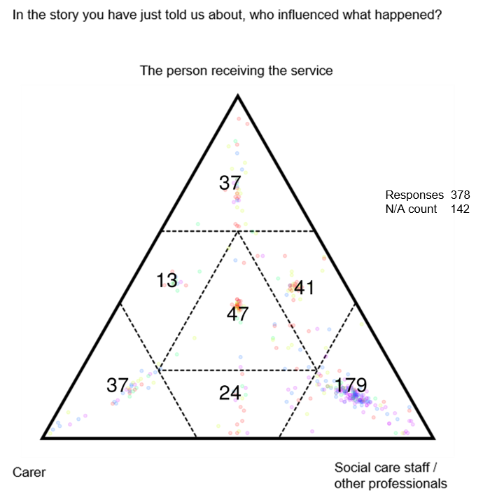
Figure 17: Responses to the question ‘Who influenced what had happened?’. Numbers show total responses in that sector of the triad.

  - The 179 responses relating to professional input (bottom right corner of figure 17) were tracked across the responses to whether people felt they had got what they needed, had a choice and been listened to, or not. When this was done, only 19 responses indicate that they had got what they felt they needed, had a choice and been listened to, while 119 indicate that they had not.

  - This suggests a correlation between social care staff being the primary influencers in a situation and those situations being ones in which a person has not got what they needed, not been listened to and not had a choice, perhaps suggesting that these influences have occurred with little or no input from the person being supported or from the unpaid carer,

Reflecting on the support I received…
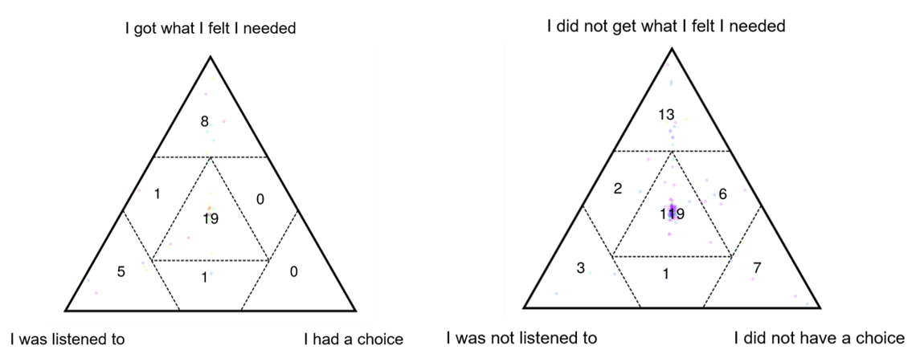
Figure 18: Responses where care staff or other professionals had been the main influence in their story tracked across whether respondents had got what they felt they needed, had a choice and were listened to. Numbers show total responses in each sector.

  - Fundamental flaws in how communication was managed and supported were seen across the stories, often creating the need for individuals to be persistent and vocal about getting the service they needed.

I have now moved to somewhere much more suitable that I like and which is close to transport routes, shops and pubs. This house though didn't have an appropriate bathroom in it and when I asked the housing association about it they didn't think they could do anything owing to the cost so I asked about getting a disabilities facilities grant which they agreed would be a good solution. I had to chase this up myself. Nobody ever told me what I was entitled to - I had to fight to get the bungalow how I needed it.

The fourth company had a co-ordinator who was very good - she was between the staff and the managers and she was up for getting it right. But then she fell and broke her ankle - the manager called 2 weeks ago, on a Friday to say they were giving us 3 days’ notice, that we had to find private care or they were going to put [name] in a home. I don’t want to be railroaded into a new contract. Now I’m paying for care myself - I know a couple of carers who had left an agency. I need some space to decide what to do for the best.

I do not like using the phone but this is the main way I am expected to get hold of information. I get confused on the phone, I can stutter, I get anxious about how they will speak to me and what they might ask - I can't always understand what they say and I'm likely to forget what I've been told, so I prefer email as I have a paper trail but a lot of places expect me to use the phone.

  - For some respondents, their interactions with social services suggested a disregard for their circumstances and a ‘hands-off’ approach that was frustrating and counter-productive for the person seeking support. Delivering more co-productive services will require greater flexibility on the part of providers and greater sharing of power so that decisions are more collaborative.

You get worn out. Every person you speak to, you’re repeating yourself again and again. If they (our children with learning difficulties) went into supported living or shared lives there would, automatically, be so much more support potentially available – we’re saving them so much money. If my son went to live with someone else they would be given £16,000 a year. They also wouldn’t need to pay for his day service and they might get their council tax paid too. We get no help at all until our child goes into care and then they get everything thrown at them.

…A social worker from the disability team rang me using language line and asked - what do you need? I explained that I could not ensure the safety of my children, for example, no matter what I do, they have no sense of danger, they are non-verbal and have challenging behaviour. His response was, we’re not child care provisions, we don’t do baby-sitting. They said I should speak to the health visitors. I am stuck in a loop with the health visitors and social services referring back to one another because of the age of my children. I was told to take my children to the play library it’s too much to take them, I need support with this. My children cannot reach their full potential.

Every meeting I have, social services want all these people involved so it takes ages to arrange and then the meetings don’t really achieve anything. I don’t know most of these people and they don’t know what I’m like or what I need. Someone I’ve met twice makes key decisions about my care. Whereas when I want a meeting, like I do at the moment, I can’t get a reply…It feels like we’re against each other not with each other.

  - As has been seen in some of the examples already, many people are prepared to take on responsibility for their own care and support needs or those of their loved ones. While assuming wholesale responsibility may be unfeasible or inappropriate, many stories illustrated people’s willingness to do what they could, and their desire to work with providers to achieve good outcomes for themselves or their loved one.

My wife was diagnosed with Grade 3 ovarian cancer in 2013 at the age of 75 and I looked after her at home until she died in 2016 apart from the last two weeks of her life. She had loads of chemo and was really sick and I had to do everything for her. The hardest was giving her a bath. I bought an inflatable cushion for the bath but she still slipped down. We never asked for help or for social services. [Name] had her own benefit after the diagnosis. We were financially secure and felt we did not need help. My attitude was that I wanted to look after her myself and I just got on with it.

Previously my support worker and I could go wherever I wanted but then a change was made that limits his mileage to 14 miles for a round trip. This means, one of the places I liked to go is now slightly too far away - 68p too far away. I suggested that I could pay this to [name] directly and he give me a receipt but that, apparently isn't possible. The extra money would need to go to [organisation] but they would take 50p away before giving the remaining money to [name].

…He’d slipped in the bath - the handles / rails that have been put in are at the wrong angle. He was really upset and frightened - he doesn’t want to go in it again. An urgent referral will be made to the OT (Occupational Therapist). You used to be able to go to a shop (for aids and adaptions) to look at things, buy them - now you can’t do that.

  - People overwhelmingly appeared to want to work together and wanted to assume some individual responsibility for their own and their loved ones’ care and support; enhancing co-productive ways of working would facilitate this for the benefit of all parties. Enacting the principles of co-production would also reduce many of the elements that contribute to negative experiences i.e. of not being listened to, of feeling out of control and of not getting the support that is actually needed.

The role of community
  - Of the 520 stories submitted, 129 were primarily about community support and activities. These stories stemmed from a variety of groups that were funded, organised and run by a range of organisations including local authorities, third sector and charitable organisations; some were user-led and run, and in some cases, a mixture of these bodies was responsible for a group.

  - To the individuals accessing the groups, the origins or funding of them was unimportant and often unknown. Many of the groups were run by or supported by volunteers who had previously accessed the group for support. These indistinct, flexible and very informal power structures offer, perhaps, the clearest examples of co-production and the inherent benefit that brings.

  - These stories, relating to community support and activities, were noticeably positive – 89 (69%) were identified as positive or very positive; 78 (60%) of them involved people who had got what they felt they needed, had a choice and been listened to; and 80 (62%) involved people who felt they had been treated as an equal, as knowledgeable and with kindness.
Responses from stories relating to community groups or activities
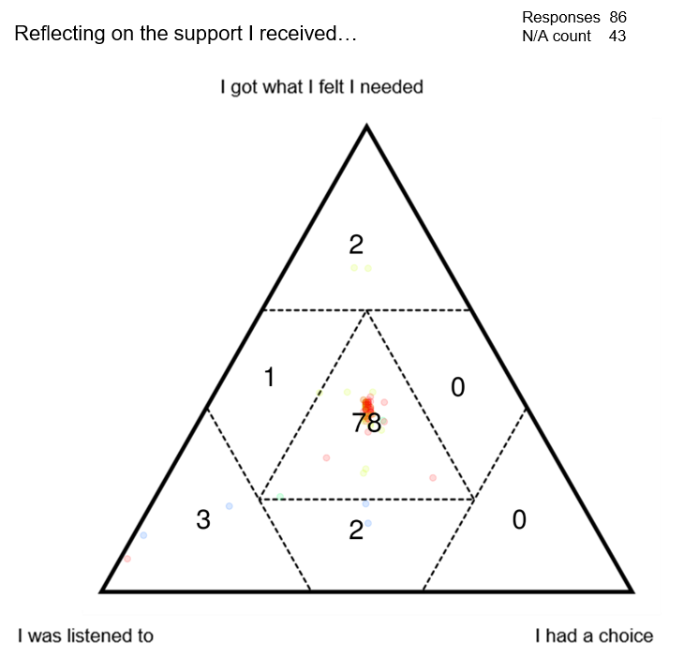
Figure 19: Responses relating to community groups and activities where people felt they got what they needed, were listened to and had a choice in their support. Numbers show total responses in that sector of the triad.
Responses from stories relating to community groups or activities
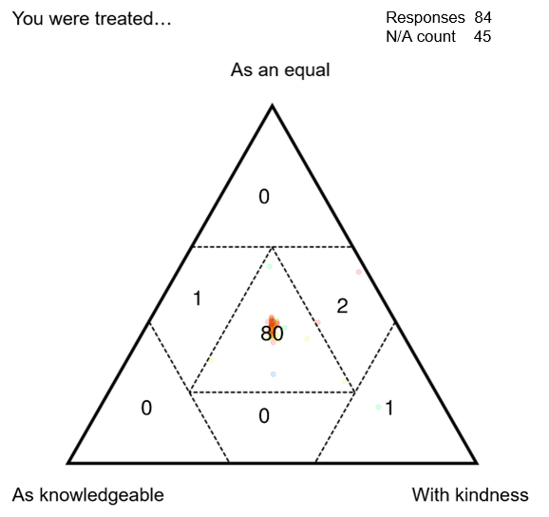
Figure 20: Responses relating to community groups and activities where people felt they were treated as an equal, with kindness and as knowledgeable. Numbers show total responses in that sector of the triad.

  - Community groups play a hugely important role in many people’s lives. They are described in stories by some as a ‘lifeline’ and many describe being unsure what would have happened to them if the group had not been there.

This group is a lifeline for me, I don't know what I would do without it. We all live round here, all look out for each other. There are some men who come, and a few different people come on different days. Fish and chips on Thursday, and a quiz. Since my husband died the group's been a lifeline.

…If it wasn't for [organisation] supporting me I don't think I would be here today. Through [organisation] I was put in touch with [organisation] who offered me counselling for six months. [Organisation] are also helping me with qualifications and employment opportunities. I attend three days a week. I volunteer on the van and we have a contract with [housing association] to look after residents’ gardens. [Organisation] has had a real positive effect on me and given me the help that I needed. I would advocate here for people who have need mental health support. It has built my confidence and given me a sense of purpose.

  - The groups were described by many as promoting self-worth and self-confidence; they were a fundamental part of people’s lives and social network. Many of the stories described how friendly people at the group were, how welcome they were made to feel, and how they now had good friends within the group.

…During this time my mental health was not good as I was worried about my mum and this was a contributing factor but not the main factor to my poor mental health. My mother passed away in 2014 and it is still painful now. [Organisation] has helped me manage the pain of losing my mother. I have been with them for 10 years. Coming here gives me confidence and responsibility as well as love. It helps me to control my depression and gives me a happier way of life. They are always here when I need them, we are like a little family and help each other. I am a peer mentor here and my lived experience helps to me to listen to their issues. Support from a health perspective has been very good and I am able to access my GP regularly but coming to here supplements that. I can lose myself here gardening. [Organisation] is the one thing I look forward to.

This group was started with some money from the Lottery and when there was a warden here, that started things going - we became a constituted group. Now we do our fund raising. Last year we collected over £900 for charities. We knit on a Monday - that goes to care homes, homeless, dementia patients. We've knitted blankets and little hats for pre-mies and things that were sent to Africa. We meet Monday, Wednesday and Thursday. I'd be lost if I didn't come here, I'd be stuck in the house otherwise.

Everyone here is really friendly. It’s nice to meet people - nice to mix with friends, and to make new friends. People are very nice - mum and I come every week, my sister drops us off.

I moved here 2 years ago because I wasn't very well and my nephew lives here so it would be easier to get around and go to appointments. I wish I hadn't – [city] is too big. I've got a nice little flat - being elderly it's difficult to make new friends - neighbours aren't very sociable. If you invite them in for a coffee there's always excuses. I've been coming to this group for a year or more, my niece did the research for me and found it - it's very good for meeting people and getting out.

  - While the social aspect of community groups was a key component of people’s positive experiences, the activities that could be enjoyed as part of the group were also very important. This was particularly clear in stories shared by people who volunteered at the groups who found this volunteering extremely positive.

I have cerebral palsy. I live with my parents. My mum is my carer and I come to the local therapy centre 3 days a week. I do reiki, reflexology and go in the therapy pool - it's really good. I also socialise with others when I come here.

My wife has health conditions and had a bad episode and was hospitalised. The silver lining though was we had conversations with a social worker and got more help. I have some mental health problems and we had been quite isolated - now we come to this centre and have got to know lots of people. I volunteer with (a local group) - and my wife volunteers as well. It gives me perspective - being empathetic is really important.

I care for my mum... Since my sister passed it's just been me which has been tougher. I've got no idea if she might be entitled to anything. She never complains. I couldn't leave her for any length of time (holidays, for example), I don't feel as if I can. Get-togethers like this one are lovely for me to see my friends (I volunteer with the group).

I started my voluntary work at 31, I am 92 now and I am still a volunteer. I started volunteering at the cafe (an Alzheimer’s group for carers) after taking my wife here when she was alive. The lady who runs the group is excellent, the actives we do are on the ball, like a film talk about birds, a lady talking about tax. We have different people coming here. I help the people here and talk to them and play games with the men. I have to say this is the most rewarding job I have ever done.

  - Matters of communication and information were highlighted by a number of the stories related to community activities, most notably in conjunction with how people found out about the groups, which was often by word of mouth, and in terms of the groups being such a helpful source of information. A key aspect of this, raised both directly and indirectly in the stories, was that people did not feel judged at these groups, or when accessing the support they provided. The sense of a safe, reliable and consistent environment was clear in many of the stories.

I try to come this group (for people with ME / CFS) every month - people here are really knowledgeable, they’re a nice bunch of people. Your own GP doesn’t often really know much, if they’re interested then they may have done their own research but generally they don’t know much and it doesn’t matter what you say they just don’t understand. But everyone in this group does understand. People share information and provide support.

My husband is away with work a lot and he's my main carer so I'm trying to do stuff myself. It would be nicer to have someone around - you never know what's going to happen. This place (MS Group) - everything is found out by word of mouth, accident. I've had people come to my house to do assessments etc. and they’re not that helpful. [Name] is the most helpful person - I found out about here through her and now got an MS nurse, physio and do other activities. Apparently you're supposed to know these things without being told.

This place is very helpful - the communication, you’re bound to see someone you know and you feel better when you leave. It’s good to get out. And the system here is really good, getting to choose your food yourself. And no judgement from anyone.

  - These stories illustrate a trend seen across all the stories, irrespective of the service they relate to, of people who feel they are part of a community and have been treated well, also feeling that they were able to discuss what mattered to them, had control over their particular situation and were also supported to prevent their situation from getting worse.

  - Although this is not surprising, these stories highlight the importance of creating environments and services that foster good relationships and illustrate the value of people being supported to maintain and develop community networks.

Co-production – summary

  - The move to working co-productively and embedding co-productive principles, particularly that of sharing power, appears to still be a work in progress for some services. Raising awareness of what co-production is, sharing what it looks like and how to work in a co-productive fashion would be beneficial across all levels of care and support services.

  - There is a demonstrable interest shown in many of the stories in people being responsible, as far as is practicable, for their own care or the care of their loved one. Approaches that nurture and work with this interest were associated with positive experiences.

  - Within the stories, a number of ways of working were described that did not seem to properly include the individuals being supported, or felt detached from them. These were generally felt to be negative and often associated with the creation of barriers to constructive, longer-term relationships.

  - Many of the most positive experiences stemmed from community groups that were asset-based, reduced hierarchy and promoted the sharing of experiences and information. They were associated with people’s confidence and self-esteem being boosted and the creation of beneficial networks and support systems. For some, the groups were a life-line and described as essential to their well-being and to their positive mental health.

  - Knowledge and information were seen as key components to building an individual’s confidence and so their ability to share power or work more closely with providers. This sharing of information, identified as a critical element in many of the stories about community groups, was also seen to reduce people’s sense of isolation and was a consistently positive component of people’s experiences.

Well-being

  - Improving well-being outcomes for people who need care and support and carers who need support is a fundamental purpose of the Social Services and Well-being (Wales) Act 2014. Well-being connects and surrounds the other principles, and it runs through all the narratives.

  - Three key themes that intersect with many of the principles of the Act, as well as a number of the issues described elsewhere in this report, stand out in relation to well-being:

- Recognising mental health needs
- Valuing unpaid carers
- Embracing the role of the family.

Recognising mental health needs

  - Mental health conditions have been discussed in relation to a number of the themes that emerged from the stories, both in terms of the detrimental effect being a carer or trying to obtain appropriate care and support can have, and in terms of the positive impact the right support can have.

  - Of the 520 stories that were submitted, 75 were primarily about mental health conditions or services, while many more touched on the issue. These 75 stories were broadly more negative than positive, and between them, they specifically related to almost all the other service categories (15 of 17 categories), indicating how interwoven experiences of mental health problems are with all other experiences.

I have support for 1 hour a fortnight from a part time worker through a local organisation. We also have a group activity once week which we have some say in but also comes down to what the organisation needs it to be. My support worker is really good but an hour a fortnight is too little really, it needs to be on tap. So much time is spent waiting. Emails and texts won't be answered for days. It's not her fault, she needs to turn her phone off. She's helping me with my housing situation now - we've got an appointment next week and our time will just be on that, I would like to get together beforehand but that won't be possible. She's very humane, very good when she's around.

I had a PIP assessment last week and it was okay but I had to go through everything again. Since all of this began, at every step I have to go through everything again. Traumatic conversations need to be repeated again and again. And there's no guarantee about anything. It makes me feel that no-one takes mental health seriously. And when you've repeated everything then you're still waiting, everything is about waiting.

I was having a carers' assessment. The social worker who came to the assessment phrased all the questions really negatively. She asked me what the reason for the assessment was, what had brought us to this point. I said that my daughter had tried to commit suicide, at which point the worker stopped me and said, ‘it's not a crime, she won't be going to jail, she tried to take her own life, she didn't try to commit suicide, I'm very passionate about that’. Needless to say, the assessment didn't go well and she didn't offer me any useful support, I ended up referring myself to other forms of support.

For the past ten years or more I have had lots of mental health problems. I'm from Sri Lanka - I experienced war, lots of bad things, I saw a lot of bad things. Now they are in my head. I have horrific memories. I have self-harmed and tried to kill myself three times. I get support from [organisation]. And there are some church people that provide some support. But I need some other help - I cannot really lift things, I need help with shopping but no one can provide that. And in the past they have stopped my benefits - I had to go to court. I feel like you're not believed, it’s very difficult.

The staff were not trained to deal with the specific mental health problems of the residents, management did not have the knowledgeable staff with regards to benefits that they said they did, the health board refused to hear my side of the situation, this has resulted in my being afraid now to voice ever again my unhappiness with the system, and I am now left largely unsupported with a serious mental health condition in the community living alone, when if things had gone right it would have been a very different story. Even the supported housing would have been far more successful if the staff and management had been professional and if the housing benefit situation had never happened. It is all a catalogue of disasters, almost like an awful comedy. But the trouble is it is not funny to the people whose lives it ruins.

  - The impact of poor support, the subsequent erosion of trust between people and providers, and the sense of isolation this brings may be significant and life-long. These stories demonstrate the need for enhanced mental health provision, and the importance of embedding avenues to that support throughout services, both formal and informal so that the strain of accessing it is reduced.

Valuing unpaid carers

  - Unpaid carers provide vital support in homes across Wales; their well-being is fundamental not only to themselves, but also to those that they care for. However, a number of stories from carers outline people feeling guilty, frustrated, isolated and upset. These feelings are heightened when mechanisms that were designed to support carers and enhance their well-being are not utilised, or are utilised ineffectually.

  - Of particular note were carers’ assessments which appear to be delivered inconsistently and do not necessarily provide the level of support anticipated in the legislation, or the form of support that would be most beneficial to the individuals involved.

I feel like I’m being greedy because I ask for things that are needed, things that are mandated. I said that Carers Needs Assessment are a duty - they say they don’t have the resources. They try to stop the Act happening - they don’t offer assessments…

Social services have been to see me twice and there’s been no suggestion of a carer’s assessment. Nothing has been offered to me. I am constantly worried. I have so many appointments for my children to go to and I always worry I may have missed some. I was really worried about post-natal depression - all of this has been discussed with the social services and they have not done anything.

I was told I couldn’t have a carers assessment because the needs of my child. I spoke to someone from the local learning difficulties team and because they pushed and pushed for months for it, I have, finally just had a carers’ assessment. The person who did it told me that she sees I have needs but that her team (she’s part of children’s intake) could not meet those. This has been reported but nothing has happened. There’s no funding anywhere for this group of children or for those that support and care for them so no one would look at any of it.

  - For many carers, respite is a critical form of support that provides a break for both them, and the person they care for. The value of respite is clear from a number of the stories.
It was a big decision for us to request respite care for our son but after our social worker suggested it for a second time, we knew it was the right time. Our son was 7 and our daughter a year younger, and as a mum, I felt she was missing out on my time and attention. Our son now has respite care twice a month, he's picked up from his special school and he says he's going for a sleepover with his friends! He loves it, he has some independence and the sense he's having fun with his friends like his sister does…

I live with my sister… I go for respite near [town] - we go out and do lots of things. [Name] and [name] live there all the time and I get to see them when I go there…

My mum died about 12 years ago then my dad went really downhill. I haven’t been able to grieve for my mum because of how much care my dad needs. He lives with me - he goes for respite now a bit more - booked in for June, July and August for a week at a time, because he’s been going there for a while it’s easy. I book ahead - some places won’t let you do that.

  - For a number of respondents, however, respite services were difficult to access or too inflexible to provide the support that is needed. In some cases, bureaucratic processes limited people’s ability to engage with, or benefit from, local services.

I have two sons, one who has Downs Syndrome and his younger brother who doesn't. I wanted two hours respite every two weeks to be able to give my younger son some time and so that not everything revolved my older son. We'd gone to the beach one day and my younger son wanted to collect shells and explore but my older son just sat down, refused to do anything and we had to go home. I just wanted to be able to give time to both sons. But the request seemed to coincide with the local authority having their budgets cut so they said no.

We can’t just say we want to go somewhere, we can’t go away. And you wouldn’t want to be away in case something happened. People don’t like respite - there are only 5 beds and most are for emergency - it’s booked 6 months ahead. They couldn’t fit all my nights of respite in because of how many people need the service, and you don’t necessarily get them back or rolled over if you can’t take them. You book 6 months ahead but anything can change in 6 months.

My husband has a Huntington’s disease and I care for him - we have support with this too. I would like to get some respite plans in place in anticipation of his condition getting worse and me needing more of a break. when I've enquired about this, the conversations I've had have been really confusing, it seems I have to wait until I need the respite before I can get the information I need but I'd prefer to know about options, how it works etc. ahead of that. I've been told to look into direct payments but I don't really know what these are and my husband's needs are all classed as health care...

  - The mechanisms to support unpaid carers exist and, in the case of carers’ assessments, have been specifically legislated for, yet the reality for some is that this support is still not being provided. Offering assessments and using them as a tool for prevention and earlier intervention would improve well-being outcomes for the carer and therefore also the cared for. Similarly, the stories suggest that respite services that offer more flexible options, promoted with clear information would enable the breaks that many unpaid carers, and those that they support and care for need.

Embracing the role of the family

  - Alongside the many stories about one family member caring for another, a significant number of stories described families with multiple, co-occurring health conditions and support needs. Others described intergenerational care within the family, particularly in relation to grandparents caring for grandchildren.

  - The family is an entity – if one person has care needs, often the whole family is impacted, particularly when it involves children. Stories described situations in which people were caring for one another or caring for someone whilst being unwell themselves; many of them highlight the lengths people must go to to secure support or to manage the situation themselves.

I have three daughters, two of whom are disabled. My youngest is well supported because I have demanded it - it's because I shout a lot… I worry about what's going to happen to my daughters when I die. My oldest daughter and her partner have moved back to the area to help but that's a pressure she should not have to have felt.

My daughter and I care for each other. If my hands aren’t working she has to feed me, give me medication - my hands and arms paralysed up the elbow, I can’t move them at all. The pain is excruciating…but my daughter has her own things she finds difficult, she has mental health problems. She and I live together - she has mental health problems (and I have arthritis). She is very up and down. When she kicks off, she really kicks off, and it’s me that she goes to. At the end of the day, how do you manage that? Especially if I’m ill. We have access to the crisis team, and they will talk to me if needed, but she’s not under a psychiatrist. Isn’t that what mums do?

I've got three children - one with ME and two with ASD, one of whom also has severe depression and anxiety. My husband also has depression and ASD. I've got lupus and my parents are currently falling apart. My lupus means I experience brain fog, fatigue and aching joints. My daughter with ME is currently flat out on the sofa and not in school. She's in her GCSE year and was coping with a reduced timetable but then was unwell this year and unable to do anything. Now she's missed school and going back is daunting. I'm also supporting my older daughter through A-levels as she struggles with motivation and I'm working with her to put structure in.

  - The inevitable wider impact of someone in a family needing care and support could be seen in a number of the stories. They demonstrate the additional, more hidden pressures that arise when someone in a family needs support, and the pervasive challenges this can bring.

The isolation is so hard. You’re not a normal family, you can’t invite people over, it’s difficult for the children who don't have additional needs - I know one of them feels resentful. It’s a lonely experience when you’re constantly battling for one child, the others are neglected somewhat…

…Initially we were caring for him in the family - I have 4 daughters and when I phoned for an assessment for me and my husband I was initially told by social services that I wouldn’t need any help because I had family around… We couldn’t get a care package to help him until he was doubly incontinent and then he had to go into a home because there weren’t enough carers for home care and then he had to move to a specific home that could support him. Had 2 social services assessments in 3 months because of how quickly everything escalated…It’s really affected the family - we had different opinions about how he should be cared for. You go through a whole roller-coaster of emotions.

I am a carer for my husband who is 47 and has late stage MS. We don't live together any more, we separated about 6 years ago when caring for him became too much to manage. He still lives in the large 'family' home which had been adapted for him with hoists and level access, and a care company comes around 4 times a day to help him get up, dress, eat, go to bed. I rent a small flat nearby and go to the house every day to help him with managing the household - cooking, cleaning, banking, etc. His sister and my parents also help out as much as they can but his condition has deteriorated rapidly over the past few years and we've come to the conclusion that it would be better if he moved into sheltered housing. We can't cope financially anymore with paying a mortgage as well as rent despite me working full time, and our two children are suffering from his inability to parent them adequately in my absence (they spend some nights at the house with him, with my father also present, and some nights at my flat)…I feel like we're stuck. If he wasn't disabled, we'd be able to sell up and both move on, but we can't do that, and there seems to be little help for anyone in our situation. He's not ready to move into a residential care home but I feel like that may be our only way out of this situation.

  - Several stories described complicated situations that were alleviated by local support that offered information or reduced isolation and supported people to create networks and develop a sense of community.

[Name] was originally a carer for her son who had an acute condition and spent a long time in hospital - she was never referred to other services. She became a friends and family foster carer for her grandson, and still there was no signposting. Now her husband has a terminal condition - he's been in two different hospitals both of which have carers info points in them, and there has still be no referral to other services. Following today's events she's been referred to a local carers group and joined an information organisation.

I am a grandparent with three grandchildren who my husband and I look after three afternoons a week after school and during school holidays. My oldest grandchild is 11 years old, has additional needs and attends a local Special School. His behaviour is sometimes aggressive and challenging, especially when we have all three grandchildren together. I attended two group sessions run by [organisation] in the school's Family Centre. I found these sessions useful as I felt we were not alone in dealing with challenges and feeling worried about our grandson…Sometimes I feel grandparents are forgotten about and we play an important role in caring for our grandson each week as both his parents work full time. Having support from [organisation] has put my mind at ease, made me feel we were doing the right thing and we have someone to turn to for advice and support. I have learned how to help my grandson control his outbursts and manage his behaviour.

  - The prevalence of multiple support needs within one family is illustrative of the complex situations many individuals face; it is also illustrative of people’s ability to support one another and to cope in difficult circumstances. Coping should not be seen as indicative of not needing support – for many, low level interventions that reduced isolation and built community were very important.

  - These stories demonstrate the need for support mechanisms that recognise the multiple roles one family member may have – mother, daughter, sister, wife, carer – and that work with, not against, the complexity inherent within these experiences.
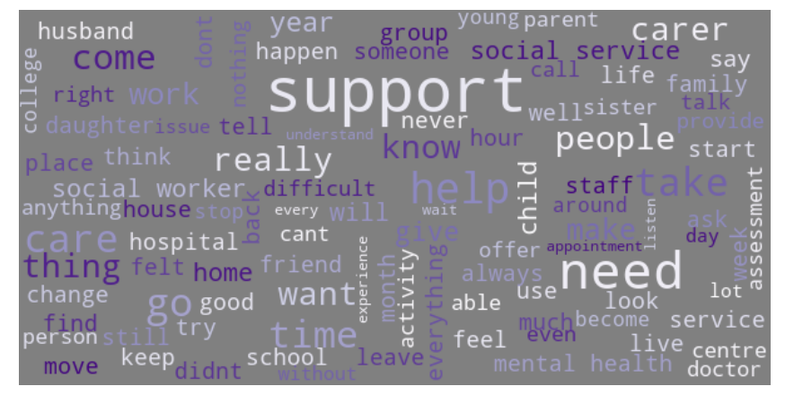
Figure 21: Word cloud generated from the stories shared by women naming a number of family members and relations.

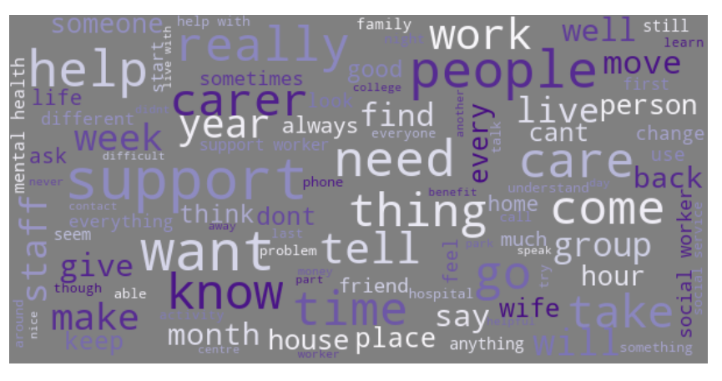
Figure 22: Word cloud generated from the stories shared by men naming fewer family members and relations.

Well-being – summary

  - The Social Services and Well-being (Wales) Act 2014 sets out ten aspects of a person’s life that should be considered in relation to well-being. There are eight primary areas and two additional areas depending on whether the person is a child or an adult. Collectively, they offer a framework for identifying and addressing need.

  - Well-being can be seen to encompass, and run as a thread through all the stories shared with Measuring the Mountain. However, it was in relation to people’s mental health needs, valuing unpaid carers and supporting families that it was evidenced most acutely.

  - In relation to these themes, the need to regard people in their entirety and work with them holistically was clearly seen. The interdependencies of someone’s life, and the impact that these have on them, as well as the prevalence of mental health issues in society generally, suggest the need for a wide lens when working to support someone.

  - The stories indicated the need to recognise and work with the structures and people that surround an individual, providing services and mechanisms that draw on, and support, those assets. Central to a number of the positive experiences were examples that described well-being as highly personal and described the activities that support it varying from person to person.

  - Among these experiences were examples of good working practices and approaches that were appreciated by the respondents. These included working closely with people as equals, listening to what they said and supporting them to explore what well-being meant to them. Some described the value of being offered carers’ assessments, others the need for creative respite solutions that offer more spontaneity.

  - Finally, the prevalence of stories about mental health issues, and their occurrence across almost all other story topics, evidences the need for increased awareness and understanding of mental health needs, as well as of the support services that exist and how to access them easily.

CONCLUSIONS

Conclusions

  - The stories gathered by Measuring the Mountain present a mixed picture of people’s experiences of using care and support services and of being unpaid carers. In some cases the principles of the Social Services and Well-being (Wales) Act 2014 can be seen prominently and keep with the aspirations of the Act. In others, they are missing and people’s experiences are at best poor, and at worst damaging.

  - With this work focused on the experiences of individuals across Wales, without input from people who work in the care and support sector, the reasons, systems and processes that underlie many of these experiences, both positive and negative, cannot be confidently discussed. However, across the stories, key themes have emerged as fundamental to creating positive experiences for people, which build on attitudes and approaches that already exist within the sector.

  - At the heart of almost all the positive experiences were human relationships and people treating each other well, with respect and valuing one another’s knowledge and experience. While some experiences talked about professionals going above and beyond, many described very ordinary interactions that, owing to their basic compassion and humanity, stood out for people, made an impact on them and were associated with positive experiences and getting the right support.

  - Many of the positive experiences described straightforward processes, offers of information and support and minimal administrative burden. Conversely, some of the worst experiences described confusing and complex systems, people needing to find everything out for themselves and processes being prioritised over people. A consistent trend among negative experiences was people silenced in some way, either not being listened to, not being able to speak or not knowing who to speak to.

  - Implementing approaches that restore, embed and nurture humanity within them will create more positive experiences, more consistently, more of the time. It does not seem unreasonable either to imagine that these approaches would also be positive for people working in the care and support sector. Being more co-productive would support these ways of working and lead to more positive experiences for people. Embedding asset-based approaches, where power is shared and relationships are equal, would go a long way towards strengthening the themes seen in the most positive stories that were gathered, and mitigating the themes that arose in some of the most negative ones.

  - As the nation continues to respond to the Covid-19 pandemic and plans for recovery and rebuilding are shaped and implemented, there are considerable threats, but also opportunities for the health and social care sector. In the spotlight created by the pandemic, the priorities laid out in A Healthier Wales continue to be the driving principles behind delivering excellent care and support.

  - At the same time, as the care and support sector itself looks to the future, with the launch of A Healthier Wales: Our Workforce Strategy for Health and Social Care, there are excellent opportunities for expanding the approaches and attitudes that were seen to contribute to good experiences for people. Focusing on the individual so that processes meet their needs, feel efficient and straightforward, and are easy to understand and engage with, would build trust early on and lay the foundation for good, longer-term relationships.

  - Linked to this wider need to ensure that positive human relations prevail throughout the care and support sector, the stories highlight several more specific areas to consider. Unpaid carers continue to describe difficulties with getting the right support and the impact that this has on their health and well-being. Many stories from carers outlined experiences of the battle they faced to secure the right information or support, and the conflict or upset this caused, particularly in light of their efforts to support their family member or loved one.

  - This struggle was also described in stories from people using care and support services and related to a range of issues, including accessing information, understanding assessment processes and feeling confident about financial support that was available. Reducing this struggle and ensuring that information and processes are focused on the right audience appears to be an urgent need. From the stories, it would seem that addressing this would impact positively on preventative support measures, multi-agency working and people’s capacity to have voice, choice and control.

  - It would also contribute to alleviating some of the mental health issues that were described in stories as either created, or exacerbated by people’s interactions with care and support services. Learning from the incredibly positive experiences described by people in relation to community support and activities, many of the answers lay in more informal ways of working that build trust, relationships, and community, prioritising the people at the heart of care and support and focusing on their individual needs and assets.

Thanks and acknowledgements

  - Measuring the Mountain would not have been possible without the incredible contributions made by people in Wales. The 520 stories that were submitted to this project represent a vast amount of information about, and means for better understanding, the day to day experiences of people using care and support services and people who are unpaid carers across Wales.

  - We would like to thank everyone who shared stories with the project, everyone who gathered stories on the project’s behalf and the hundreds of people and organisations throughout Wales who invited Measuring the Mountain to events, meetings and community groups, who shared information about the project and who helped promote the work.

  - Measuring the Mountain has been supported and guided throughout by a dedicated Steering Group of individuals who have brought their time, knowledge and expertise to the project and without whom the project would not have been possible.

Neil Wooding | Ministry of Justice
Rachel Iredale | University of South Wales
Amber Powell  David Williams  Eve Parkinson  Faaiza Bashir  Owen Evans  Rich Williams | Carers Wales  Greater Gwent Partnership  Monmouthshire County Council  Carers Trust Wales  Children in Wales  Ministry of Justice
Roiyah Saltus  Ruth Dineen  Sara Woollatt  Sue Evans  Trevor Palmer BEM  Vin West MBE  Wayne Jepson  Mark Llewellyn (Observer) | University of South Wales  Co-production Wales  Digital Communities Wales  Social Care Wales  GL100 ResponsABLE Assistance  Arfon Access Group  Public Health Wales  University of South Wales
  - This report was written by Katie Cooke (Project Manager) and Dr Rachel Iredale (Principal Investigator) with support from the Steering Group. The analysis of the stories was undertaken by Dr Rachel Iredale, Dr Roiyah Saltus and Faaiza Bashir.

Annex 1 – SenseMaker framework
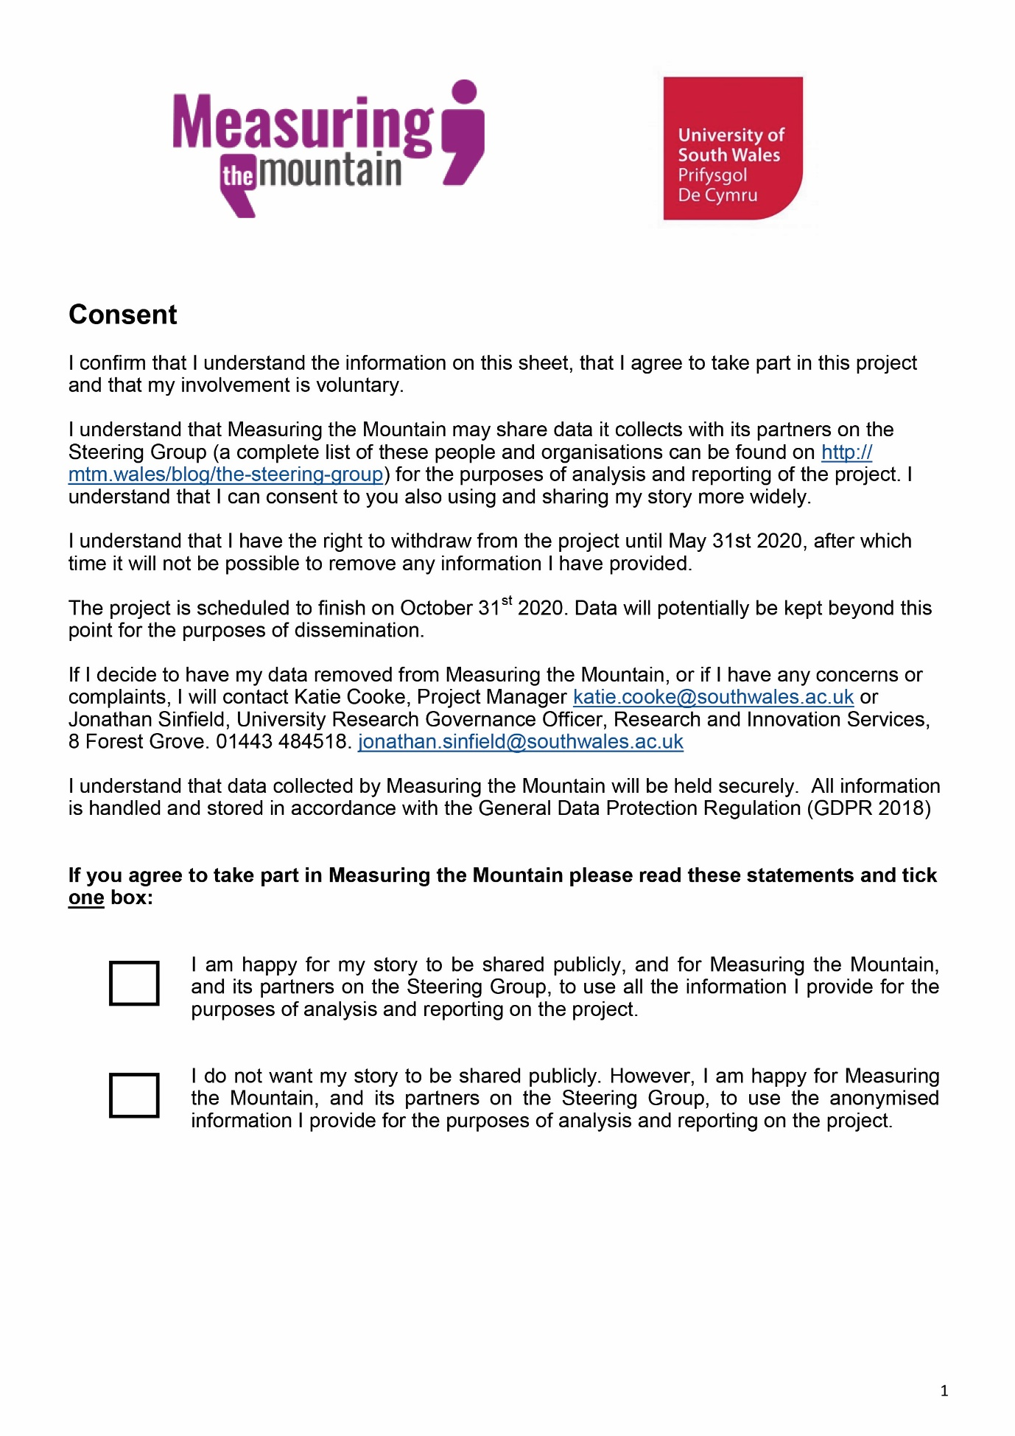
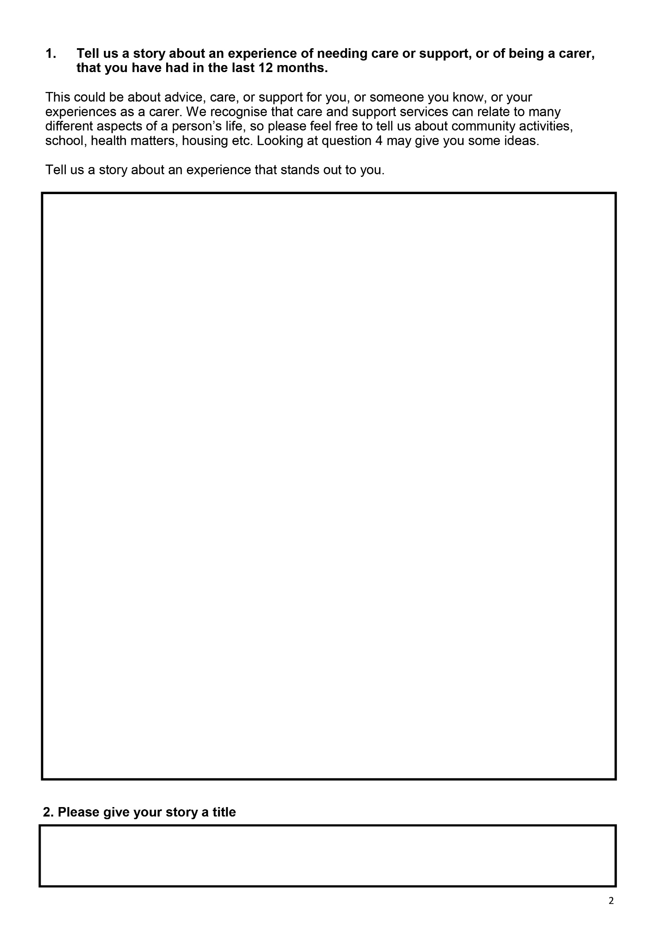
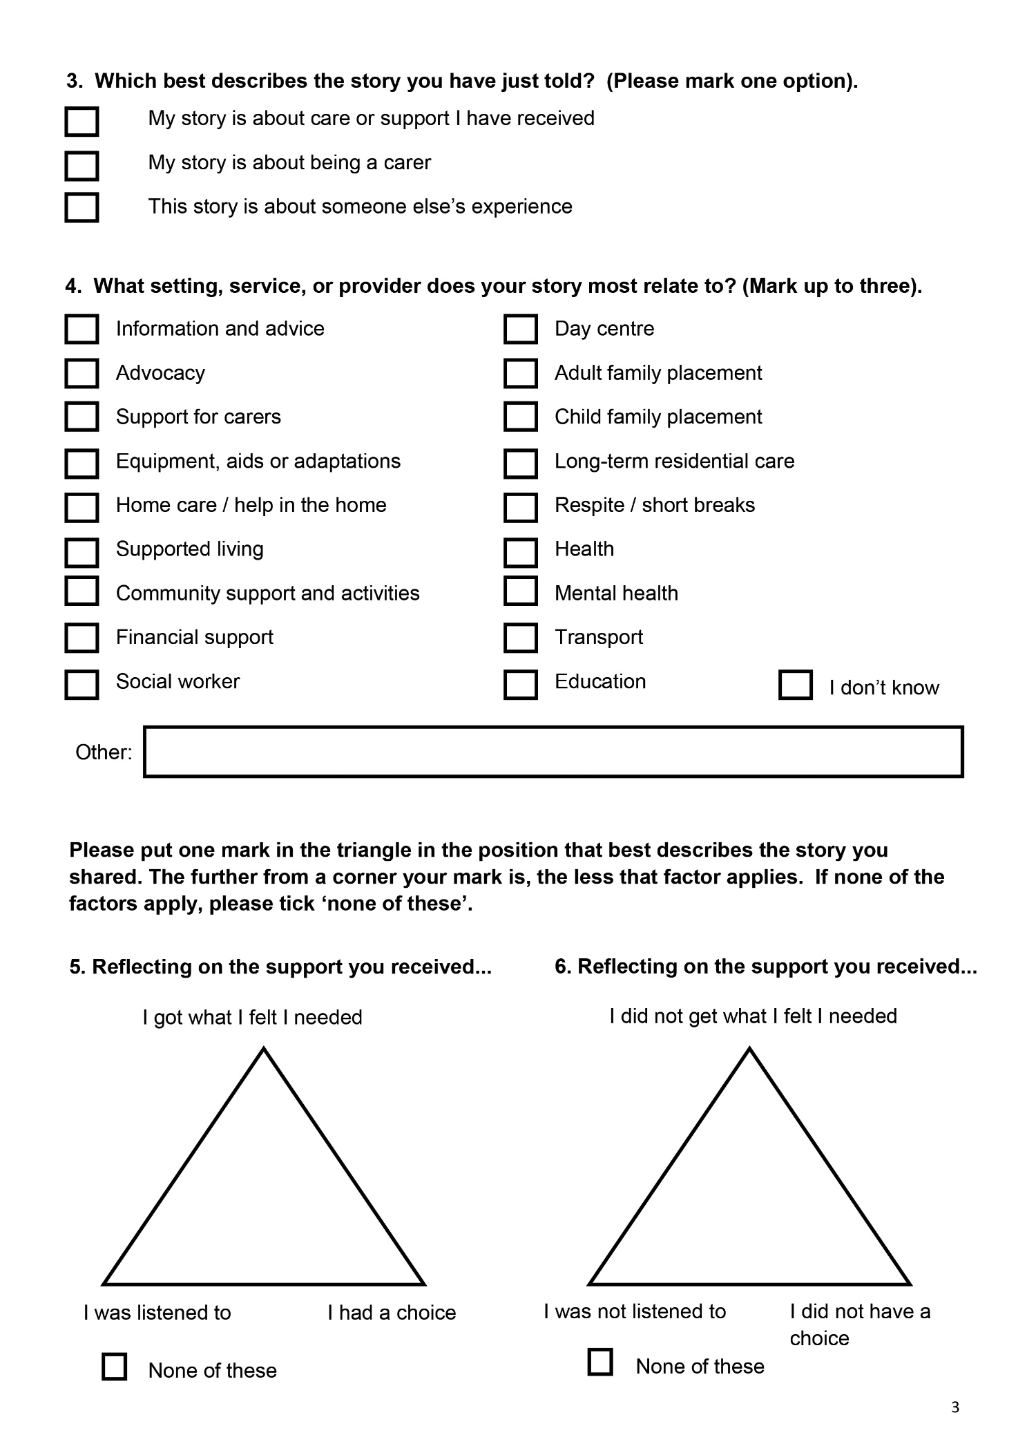
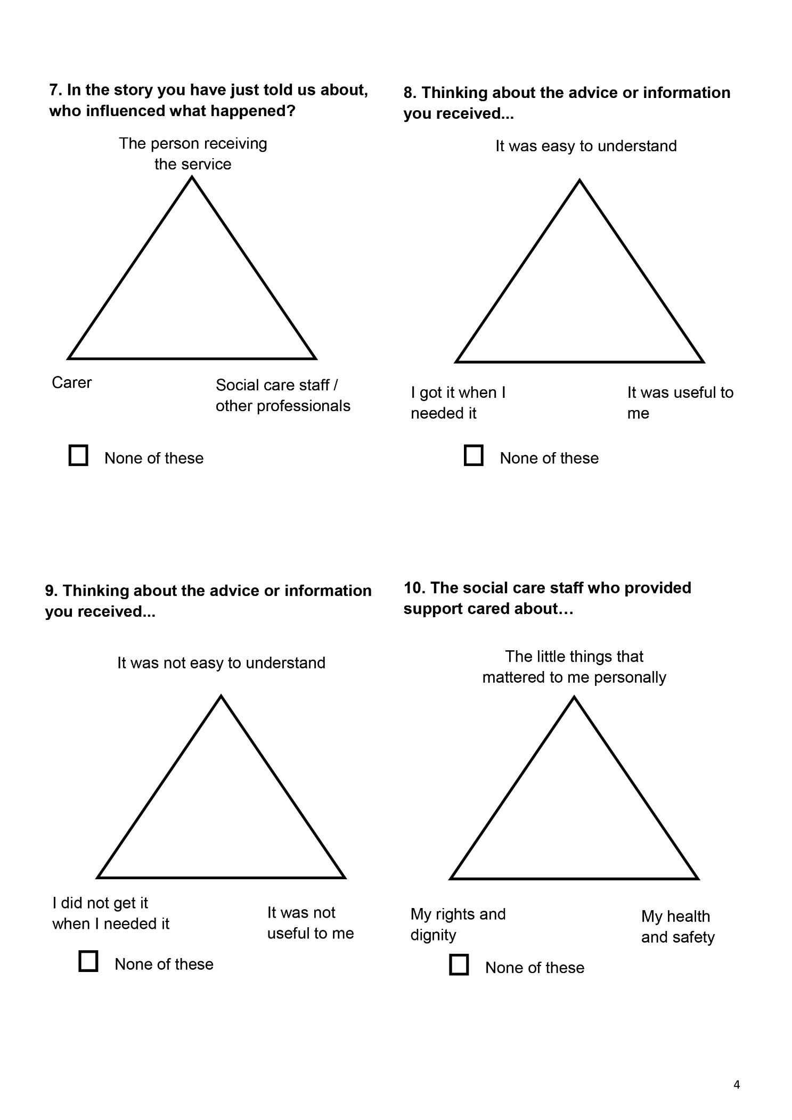
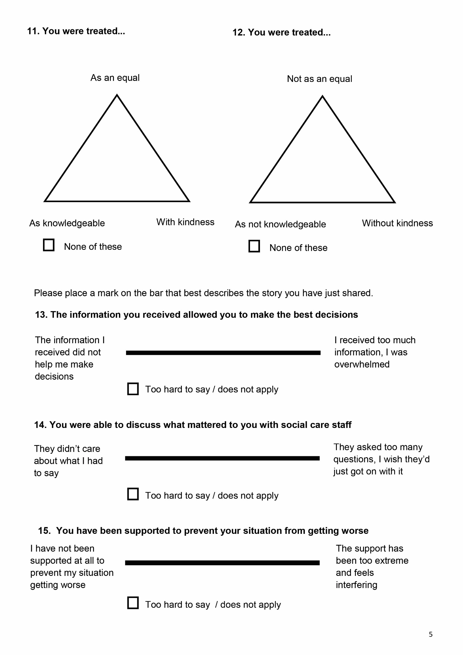
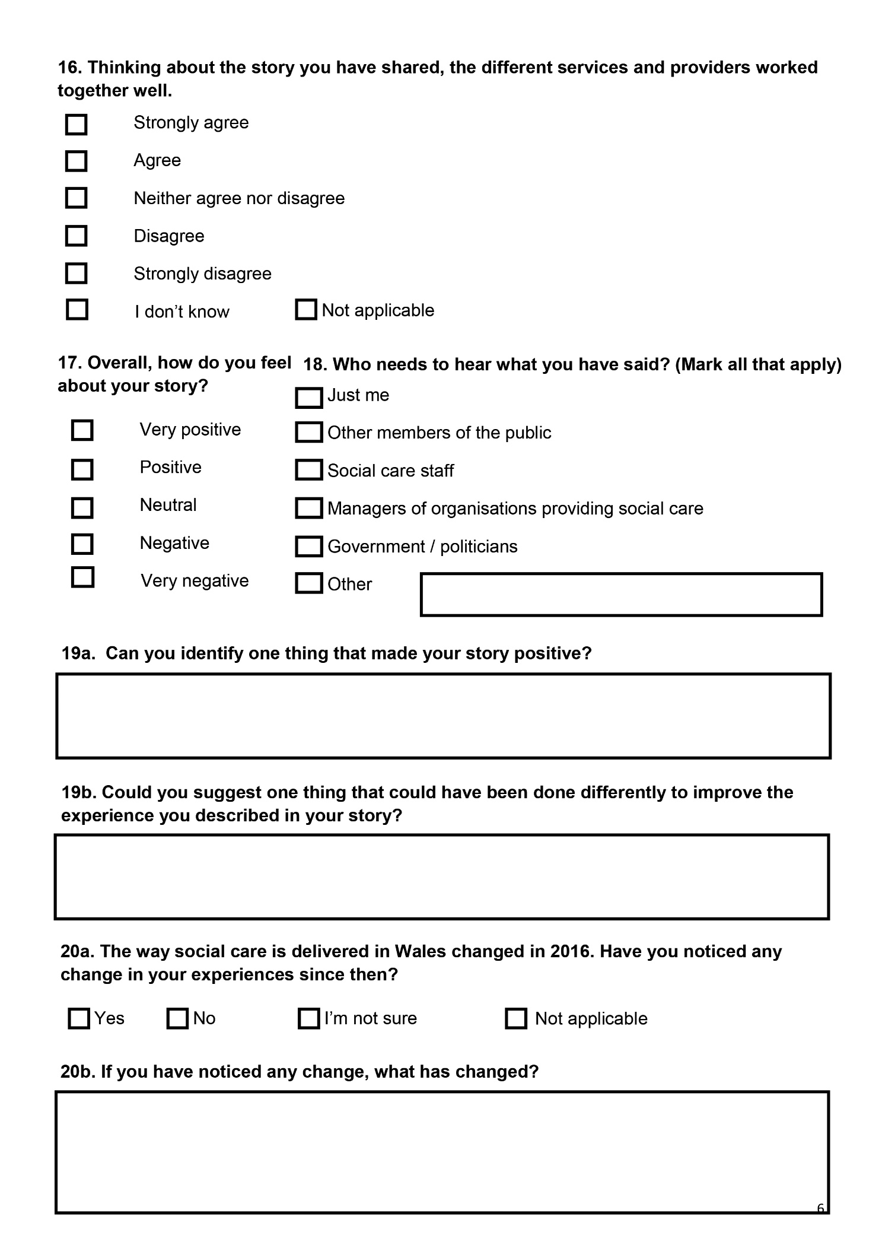
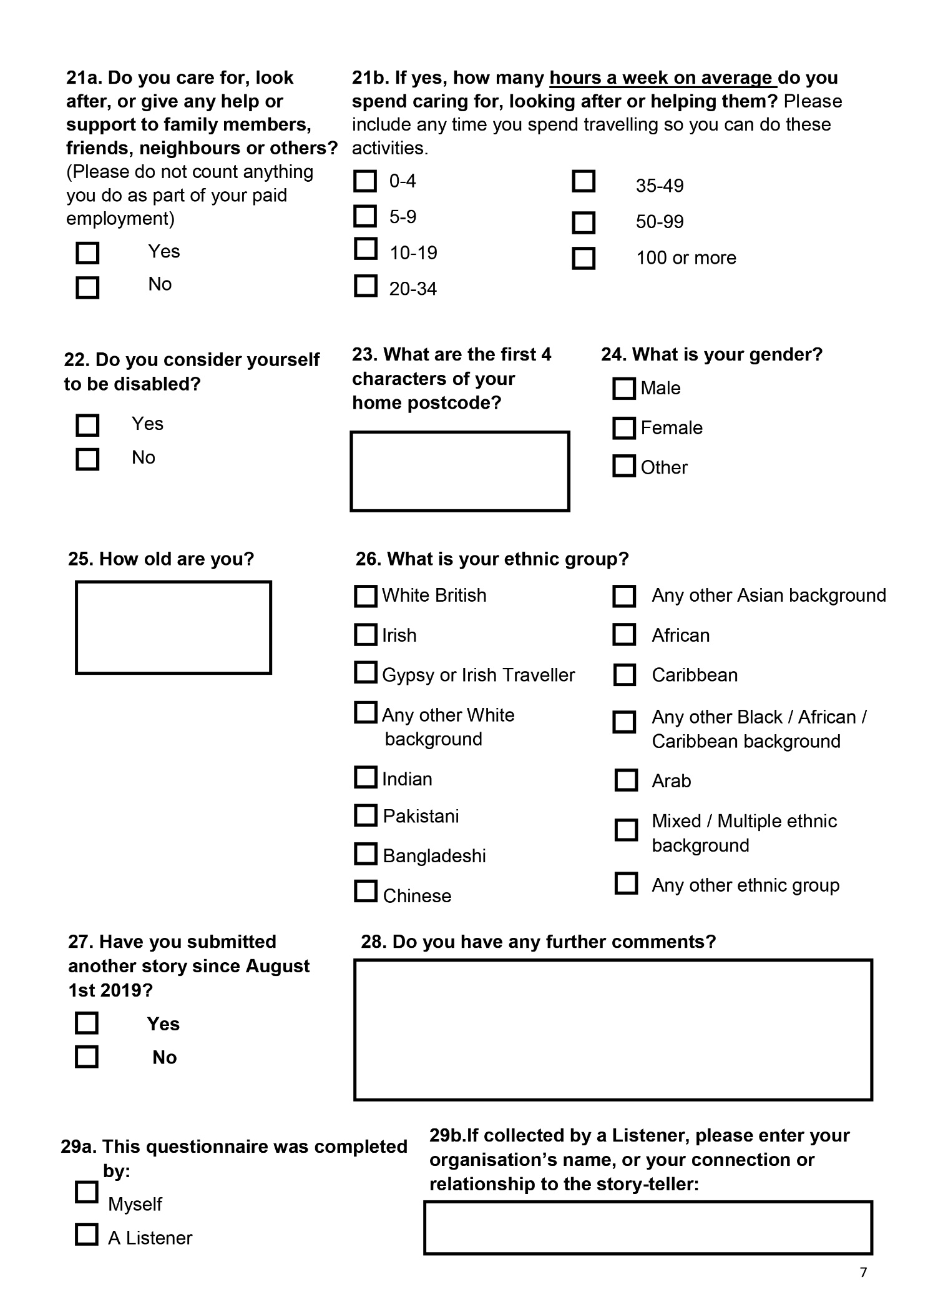

Annex 2 – Partner organisations

  - Members of the Measuring the Mountain Steering Group attended more the 40 events and groups to gather stories. These activities were hosted by a range of organisations, in some cases multiple organisations were involved. Many of these are listed below, as are organisations that gathered stories on behalf of the project. Due to the complexity of some of the arrangements and to preserve the anonymity of some of the smaller groups, the list is not exhaustive.

- Action in Caerau and Ely
- Age Alliance Wales
- Alzheimer's Society
- Anglesey County Council
- Bridgend Coalition of Disabled People
- Caerphilly County Borough Council
- Carmarthenshire Carers
- Chinese in Wales Association
- Credu Carers
- Disability Wales
- Diverse Cymru
- Drive
- Fair Treatment for the Women of Wales
- Learning Disability Wales
- Mencap
- Merthyr Valleys Homes
- Mirus
- Monmouthshire County Council
- MS Cymru
- Newport City Council
- North Wales Together : Seamless Services for People with Learning Disabilities
- People First
- Pobl Group
- Project 360
- Swansea Association for Independent Living
- Swansea Carers Centre
- The Bridges Centre
- University of Wales Trinity Saint David.

Welsh Assembly Government, 2011, Sustainable Social Services for Wales: A Framework for Action, accessed at: https://www.basw.co.uk/system/files/resources/basw_92807-4_0.pdf
Hussey et al, January 2018, The Parliamentary Review of Health and Social Care in Wales, accessed at: https://gov.wales/sites/default/files/publications/2018-01/Review-health-social-care-report-final.pdf
Welsh Government, June 2018, A Healthier Wales: our Plan for Health and Social Care, accessed at https://gov.wales/sites/default/files/publications/2019-10/a-healthier-wales-action-plan.pdf
Welsh Government, 2015, Well-being of Future Generations (Wales) Act 2015 The Essentials, accessed at: https://www.futuregenerations.wales/wp-content/uploads/2017/02/150623-guide-to-the-fg-act-en.pdf
Written Statement - Evaluation of the Social Services and Well-being (Wales) Act 2014. Retrieved from: https://gov.wales/written-statement-evaluation-social-services-and-well-being-wales-act-2014
Verity et al, 2019 Evaluation of the Social Services and Wellbeing (Wales) Act 2014: Framework for Change Report Accessed at https://gov.wales/evaluation-social-services-and-well-being-wales-act-2014-framework-change
Ibid p.5
Cooke et al, 2019, What really matters in social care to individuals in Wales? Accessed at http://mtm.wales/ckfinder/userfiles/files/MtM%20Final%20Report%20March%2019%202019.pdf
ibid
CognitiveEdge, 20.10.2009 Introducing SenseMaker® [online video] available at https://www.youtube.com/watch?v=SkRe7Xg7pk4 [accessed 17.08.2020]
Quinlan, Tony, Feb 2018 WORKING WITH SENSEMAKER – EXPERIENCES FROM THE FIELD WITH UNDP available at https://narrate.co.uk/2018/02/working-with-sensemaker-experiences-from-the-field-with-undp/ [accessed 17.08.2020]
James, S, 2018, Interlink RCT Annual Report 2017/18 available at http://www.interlinkrct.org.uk/wp-content/uploads/2018/11/Annual-report201718.pdf [accessed 17.08.2020]
Cooke et al, 2019, What really matters in social care to individuals in Wales? Accessed at http://mtm.wales/ckfinder/userfiles/files/MtM%20Final%20Report%20March%2019%202019.pdf
Gentles, S. J., Charles, C., Ploeg, J., & McKibbon, K. (2015). Sampling in Qualitative Research: Insights from an Overview of the Methods Literature. The Qualitative Report, 20(11), 1772-1789. Retrieved from http://nsuworks.nova.edu/tqr/vol20/iss11/5
Social Care Wales, November 2017, Care and support in Wales: national population assessment report, accessed at https://socialcare.wales/cms_assets/file-uploads/SCW-NPAR-ENG.PDF
Carers Wales – about carers, accessed at https://www.carersuk.org/wales/about-us
Drakeford, Mark, First Minister of Wales, 23.03.2020, First Minister of Wales' statement on new coronavirus measures Accessed at https://gov.wales/first-minister-of-wales-statement-on-new-coronavirus-measures
Cooke et al, 2019, What really matters in social care to individuals in Wales? Accessed at http://mtm.wales/ckfinder/userfiles/files/MtM%20Final%20Report%20March%2019%202019.pdf
Care Council for Wales, March 2017; Principles Resource Guide accessed at https://socialcare.wales/cms_assets/hub-downloads/Principles-Resource-Guide_March-17.pdf
Yeandle and Buckner, 2015, Valuing Carers 2015 – the rising value of carers’ support, University of Sheffield, University of Leeds and CIRCLE, accessed at https://www.carersuk.org/for-professionals/policy/policy-library/valuing-carers-2015
Social Services and Well-Being (Wales) Act 2014, section 15, 2(i) accessed at https://www.legislation.gov.uk/anaw/2014/4/contents
Social Services and Well-Being (Wales) Act 2014, section 6, 3 a) accessed at https://www.legislation.gov.uk/anaw/2014/4/contents
Social Services and Well-Being (Wales) Act 2014, section 2, 4a) accessed at https://www.legislation.gov.uk/anaw/2014/4/contents
Percutaneous endoscopic gastronomy is a way of introducing food, fluids and medicine directly into the stomach via a surgically implanted tube. Accessed at https://www.nhs.uk/conditions/swallowing-problems-dysphagia/treatment/
Welsh Government, 2015, Social Services and Well-being (Wales) Act 2014 Part 4 Code of Practice (Meeting Needs) accessed at https://gov.wales/sites/default/files/publications/2019-05/part-4-code-of-practice-meeting-needs.pdf
Social Services and Well-Being (Wales) Act 2014, section 6, 2 (a) – (d) accessed at https://www.legislation.gov.uk/anaw/2014/4/contents
Social Services and Well-Being (Wales) Act 2014, section 6, 3 (a) accessed at https://www.legislation.gov.uk/anaw/2014/4/contents
Welsh Government, June 2018, A Healthier Wales: our Plan for Health and Social Care, accessed at https://gov.wales/sites/default/files/publications/2019-10/a-healthier-wales-action-plan.pdf
Welsh Government, January 2020, Social Services and Well-being (Wales) Act 2014 Codes and guidance: Part 9 Statutory Guidance (Partnership Arrangements) Version 2, accessed at https://gov.wales/sites/default/files/publications/2020-02/part-9-statutory-guidance-partnership-arrangements.pdf
Welsh Government, January 2020, Social Services and Well-being (Wales) Act 2014 Codes and guidance: Part 9 Statutory Guidance (Partnership Arrangements) Version 2, accessed at https://gov.wales/sites/default/files/publications/2020-02/part-9-statutory-guidance-partnership-arrangements.pdf
Social Services and Well-Being (Wales) Act 2014, Part 9 accessed at https://www.legislation.gov.uk/anaw/2014/4/contents
Welsh Government, June 2018, p.5 A Healthier Wales: our Plan for Health and Social Care, accessed at https://gov.wales/sites/default/files/publications/2019-10/a-healthier-wales-action-plan.pdf
Co-production Network for Wales, What is co-production? Accessed at https://copronet.wales/
Social Services and Well-Being (Wales) Act 2014, section 2, 2 (a) – 4 (b) accessed at https://www.legislation.gov.uk/anaw/2014/4/contents
Welsh Government, June 2018, A Healthier Wales: our Plan for Health and Social Care, accessed at https://gov.wales/sites/default/files/publications/2019-10/a-healthier-wales-action-plan.pdf
Welsh Government, October 2020, COVID-19 Reconstruction: Challenges and Priorities, accessed at https://gov.wales/sites/default/files/publications/2020-10/coronavirus-reconstruction-challenges-and-priorities.pdf
Health, Education and Improvement Wales and Social Care Wales, A Healthier Wales: Our Workforce Strategy for Health and Social Care, October 2020, accessed at https://heiw.nhs.wales/files/workforce-strategy-for-health-and-social-care1/
Cooke et al, 2019, What really matters in social care to individuals in Wales? Accessed at http://mtm.wales/ckfinder/userfiles/files/MtM%20Final%20Report%20March%2019%202019.pdf
Mark Llewellyn is the Chief Investigator for IMPACT – the evaluation of the IMPlementation of the Social Services and Well-being (Wales) Act.

